**Machine Learning – Big Data Analytics Report**

**Eric Ye**

**Gitimoni Saikia**

**January 28th, 2021**

**Regression Data:**

*Properties of dataset:* The dataset sourced from Kaggle, is based on California housing prices sorted by each district/ block. It contains 20641 observations, and 10 variables. These variables include longitude, latitude, houseMedianAge, totalRooms, totalBedrooms, population, households, medianIncome, medianHouseValue, and oceanProximity.

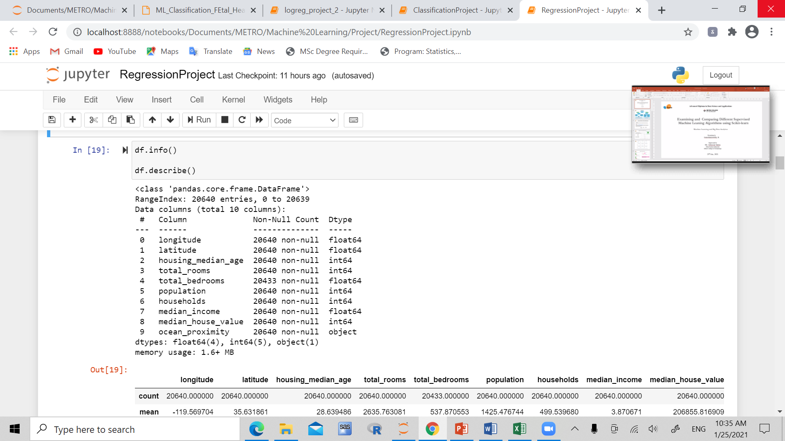

**GOAL**: To identify the variables which affect house prices the most, and find which model is best and most accurate when predicting house prices

**Data cleaning/ preprocessing**

The data was all encoded, and observations containing missing values were removed. The X and Y data frames were then created, with median_house_value as the Y dependent variable, and X as the other variables.

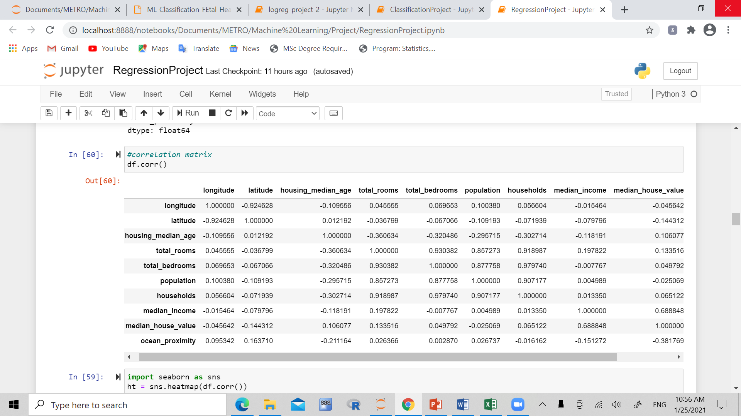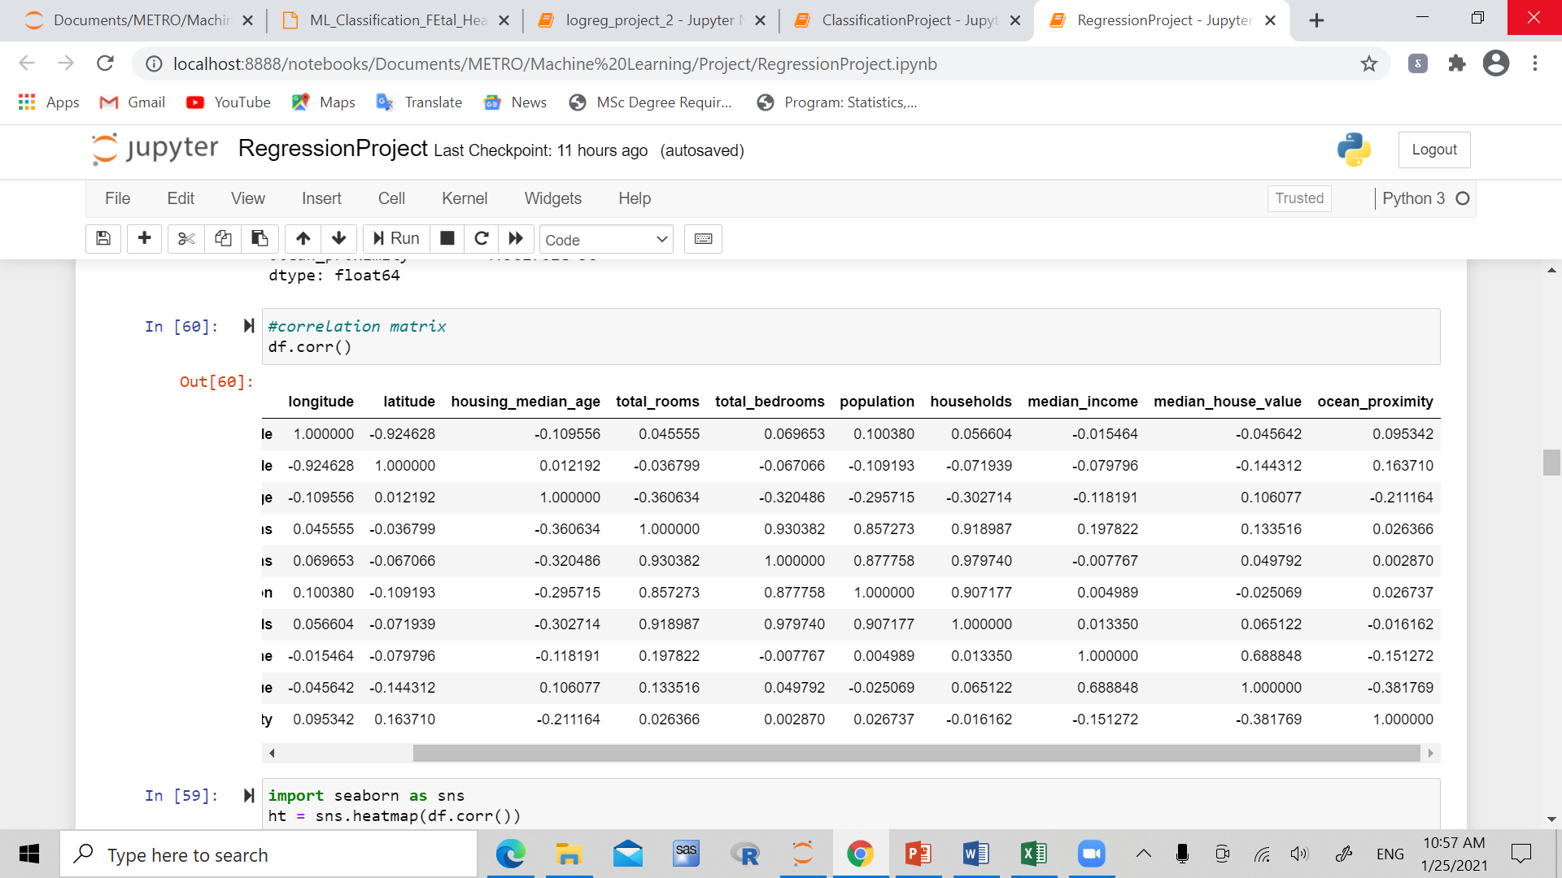

*Figure 1:* Correlation matrix for the housing variables

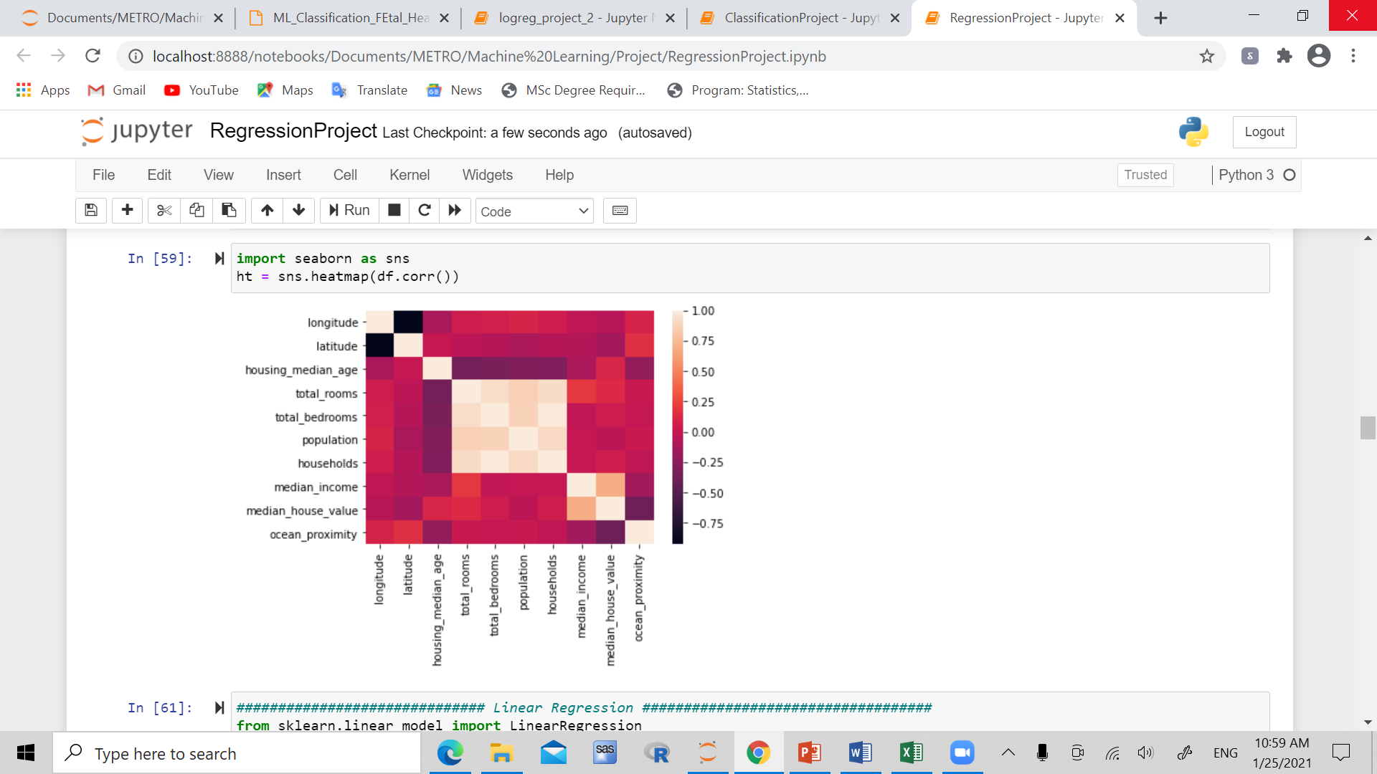

*Figure 2:* Correlation heat map for the housing variables

**Linear Regression**

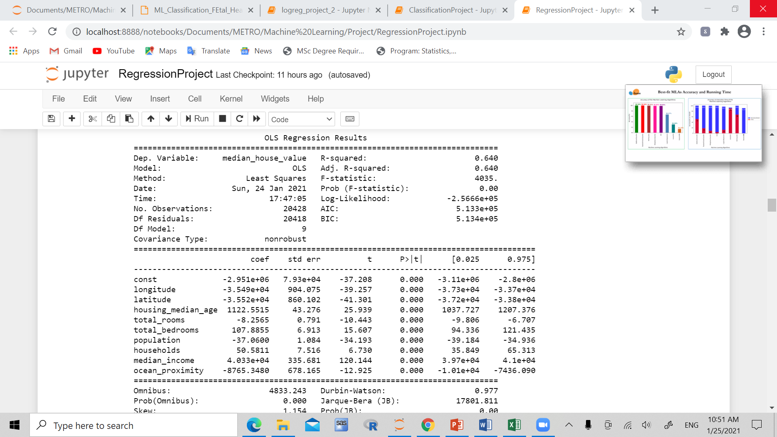

P-Values:

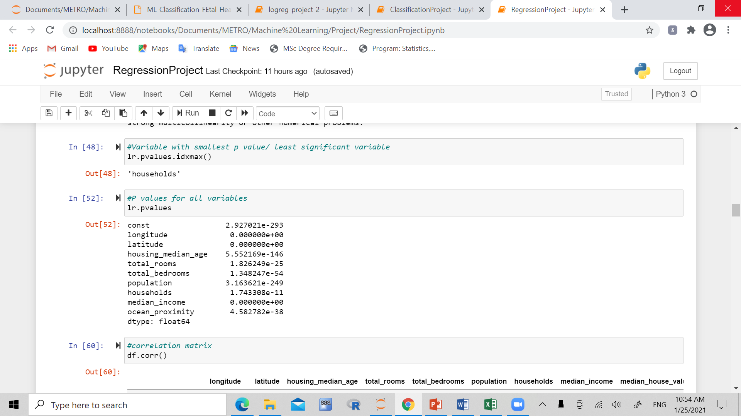

As we are shown in the OLS Regression results, all of the variables are significant, and ocean proximity, and median income seem to have the biggest correlation with the dependent variable.

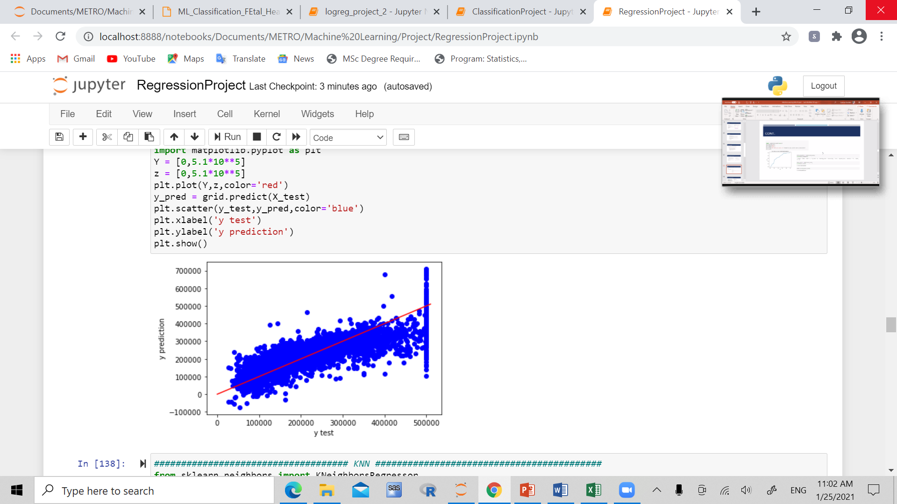

*Figure 3:* Graph of the testing and predicted y values

Best parameters, estimator, score:

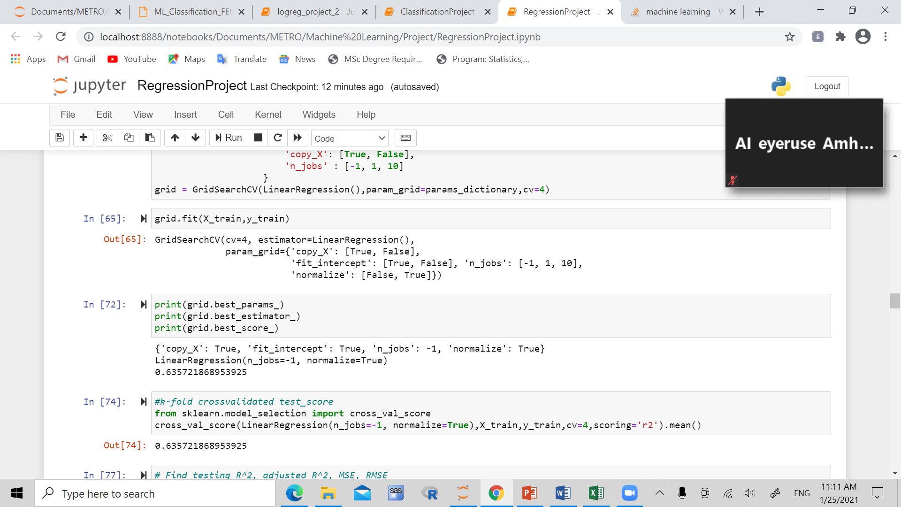

R^2, adjusted R^2, MSE, RMSE:

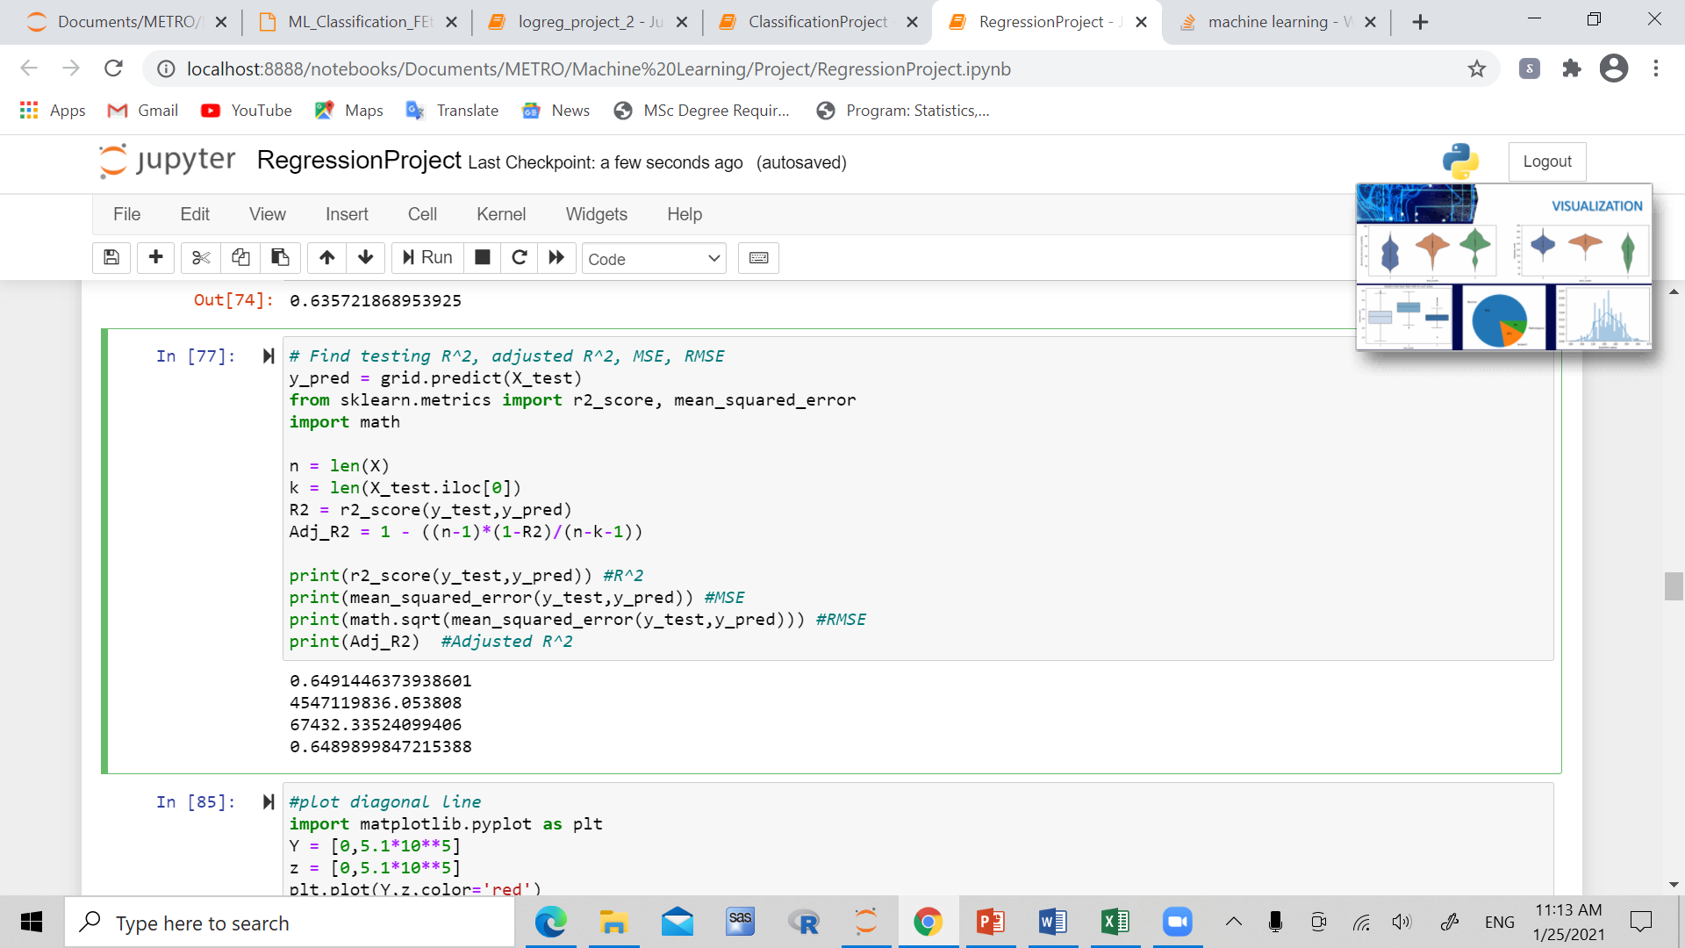

K-Fold cross validated test score:

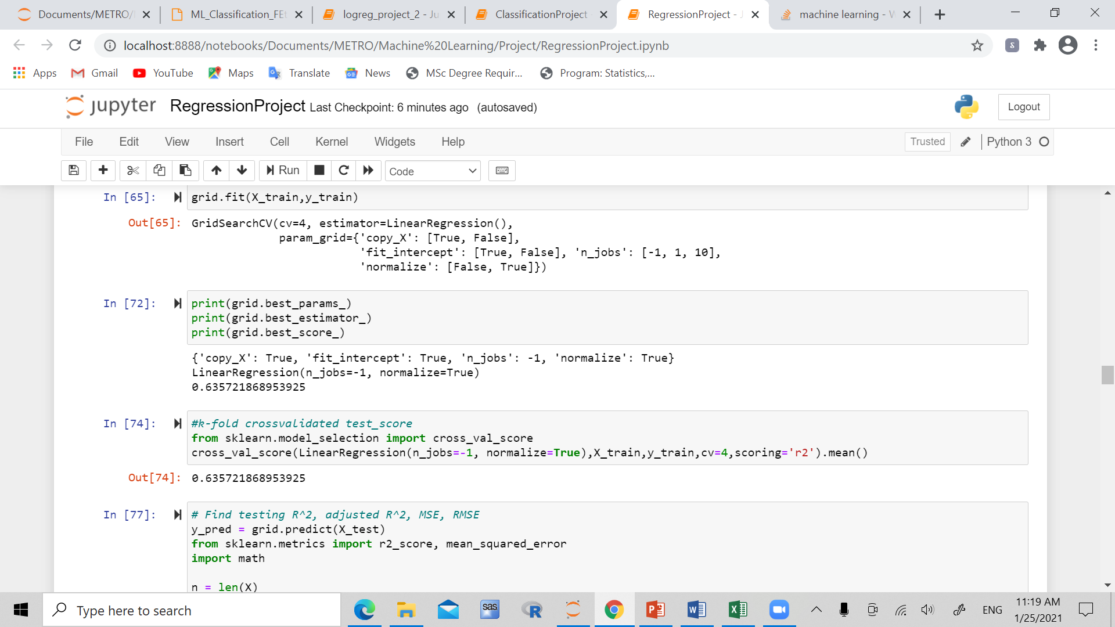

**K nearest neighbors method**

Best parameters, estimator, score:

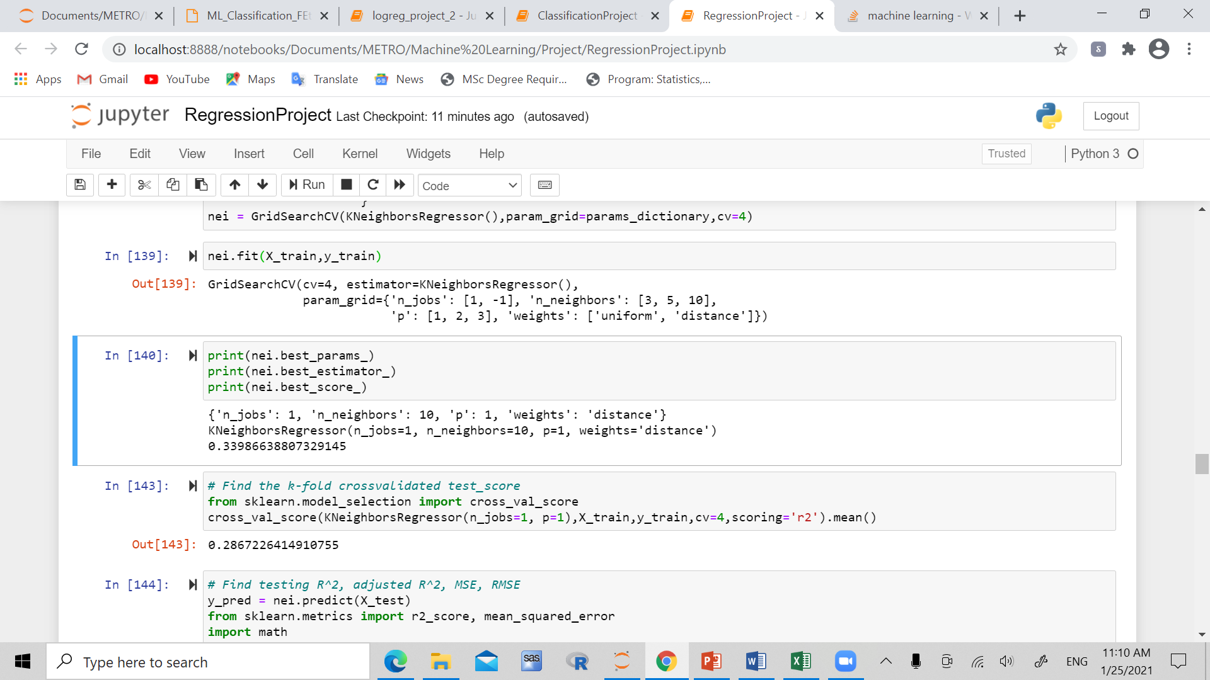

R^2, adjusted R^2, MSE, RMSE:

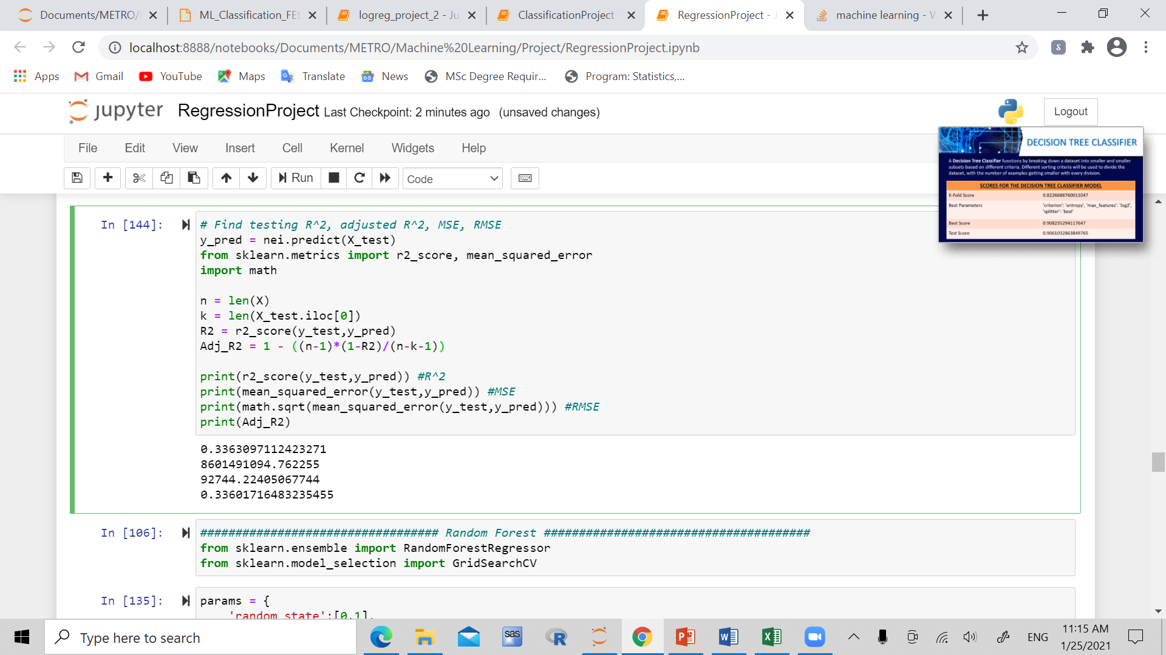

**Random Forest:**

Best parameters, estimator, score:

K fold cross validated test score:

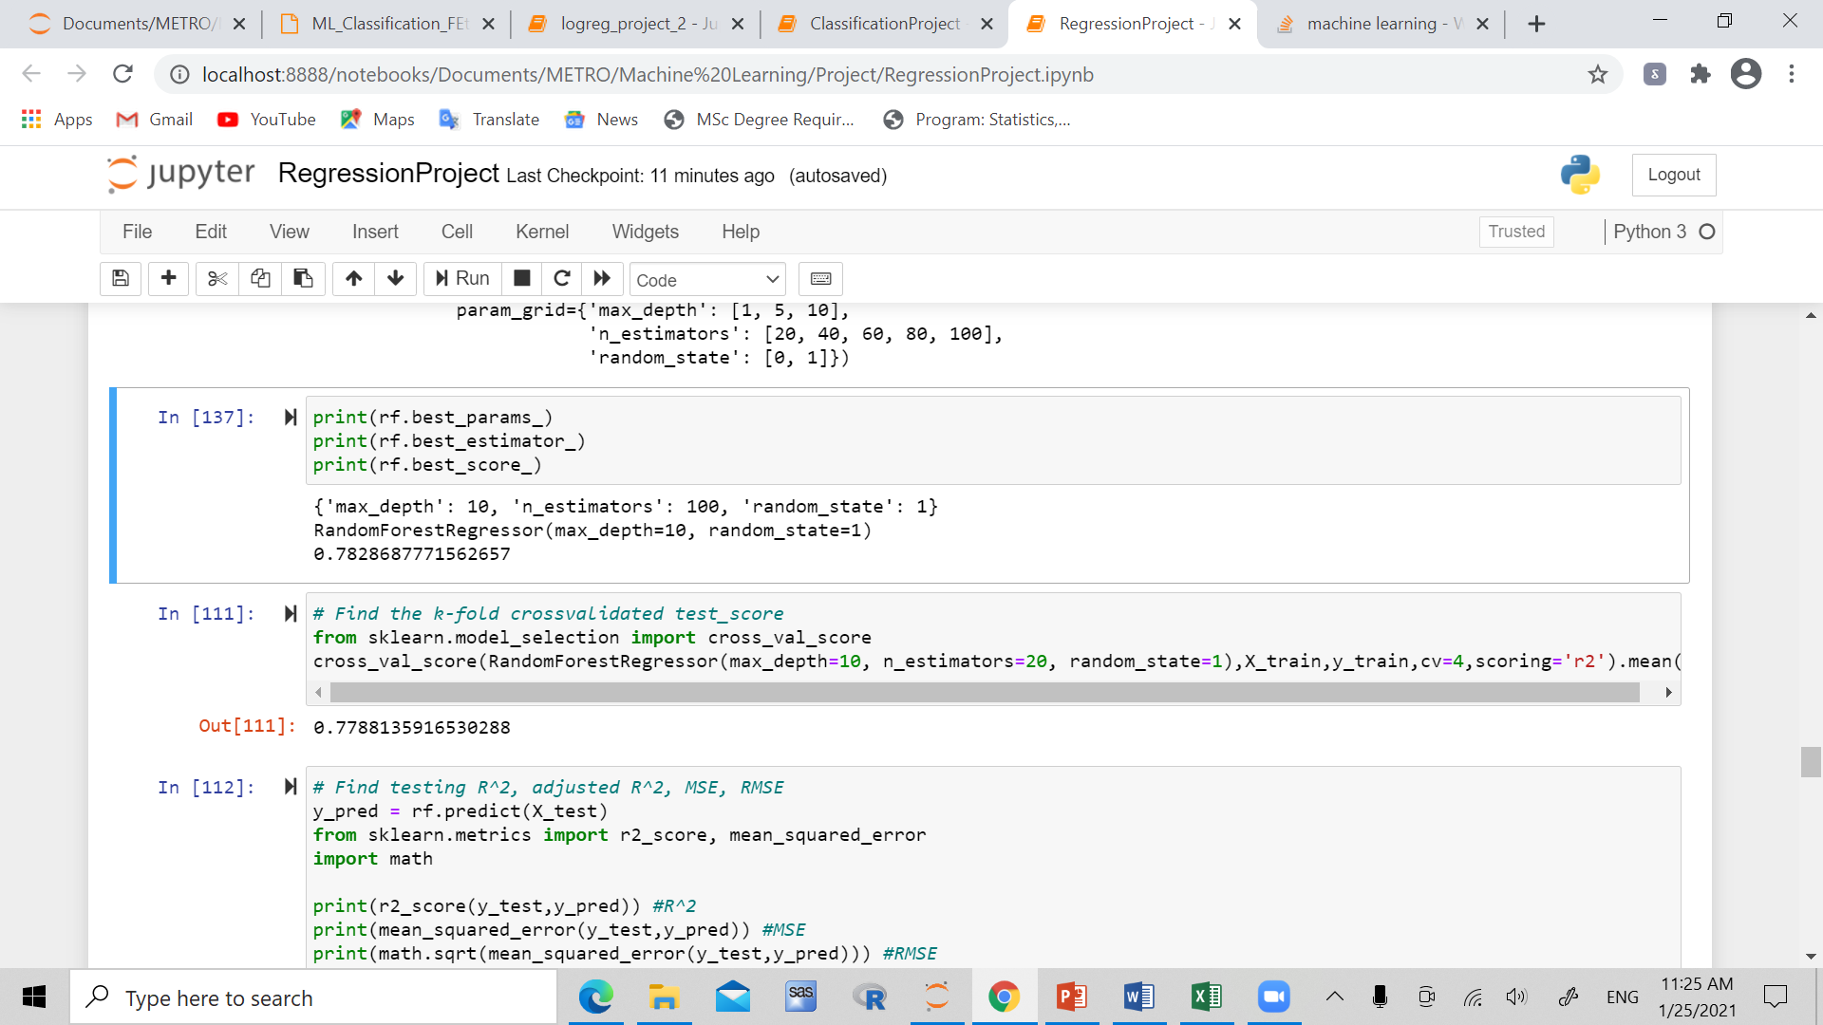

R^2, adjusted R^2, MSE, RMSE:

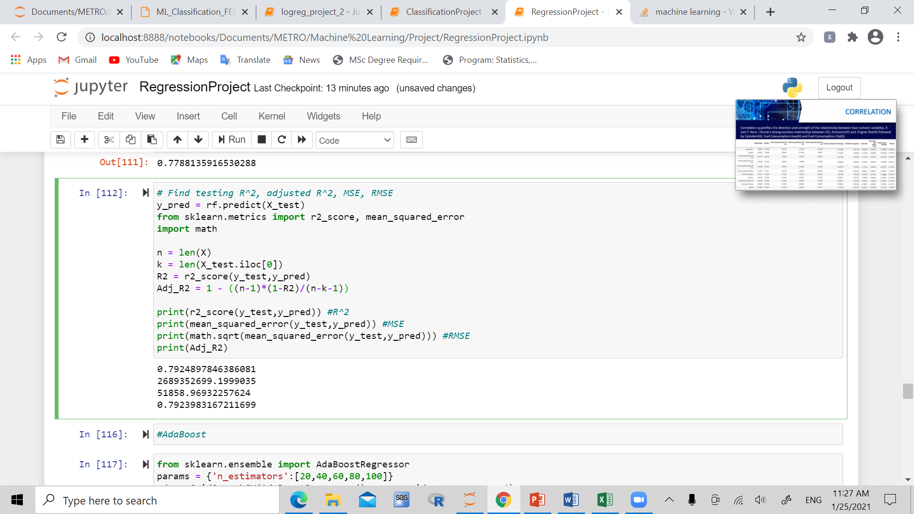

**Adaboost**

Best parameters, estimator, score:

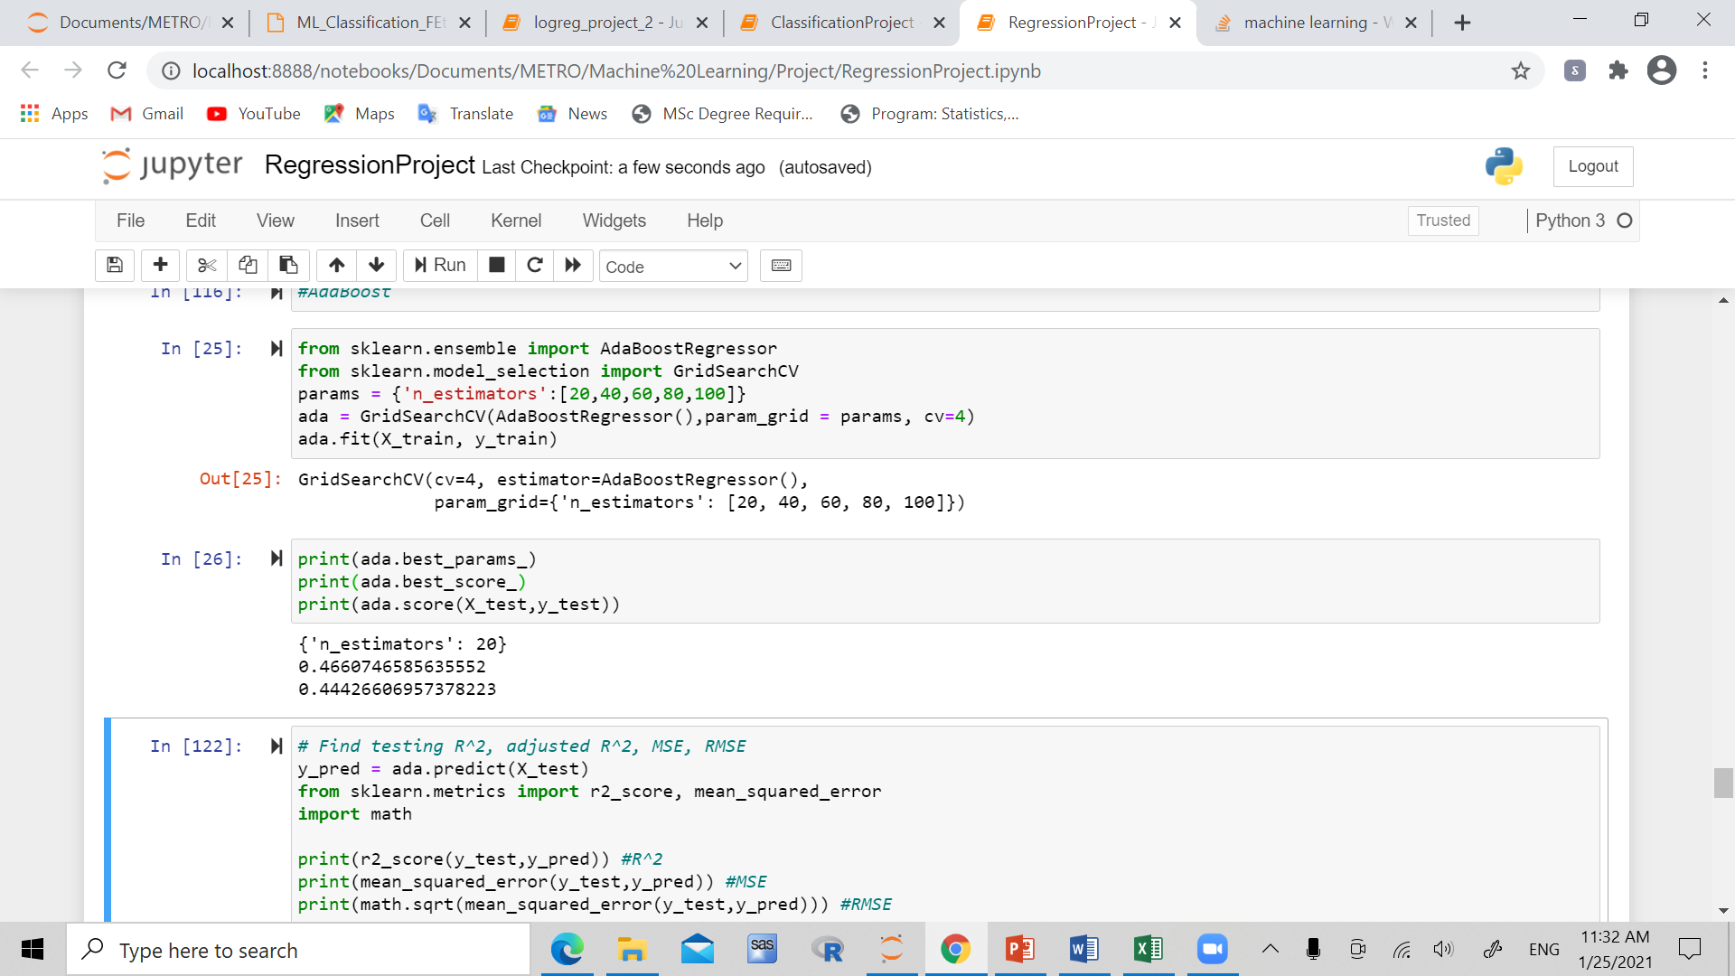

K fold cross validated test score:

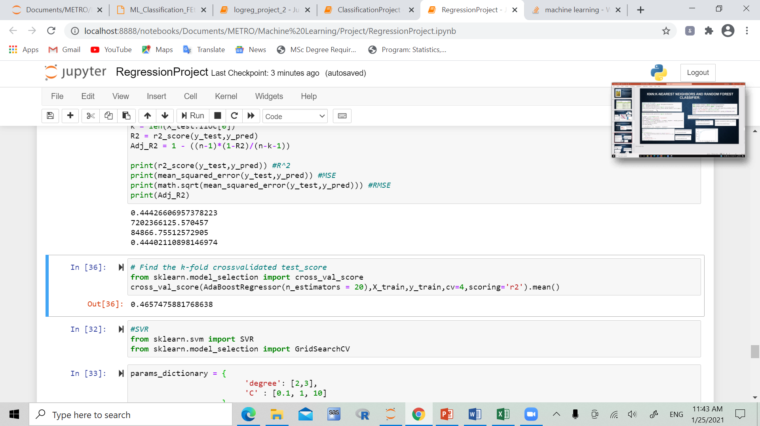

R^2, adjusted R^2, MSE, RMSE:

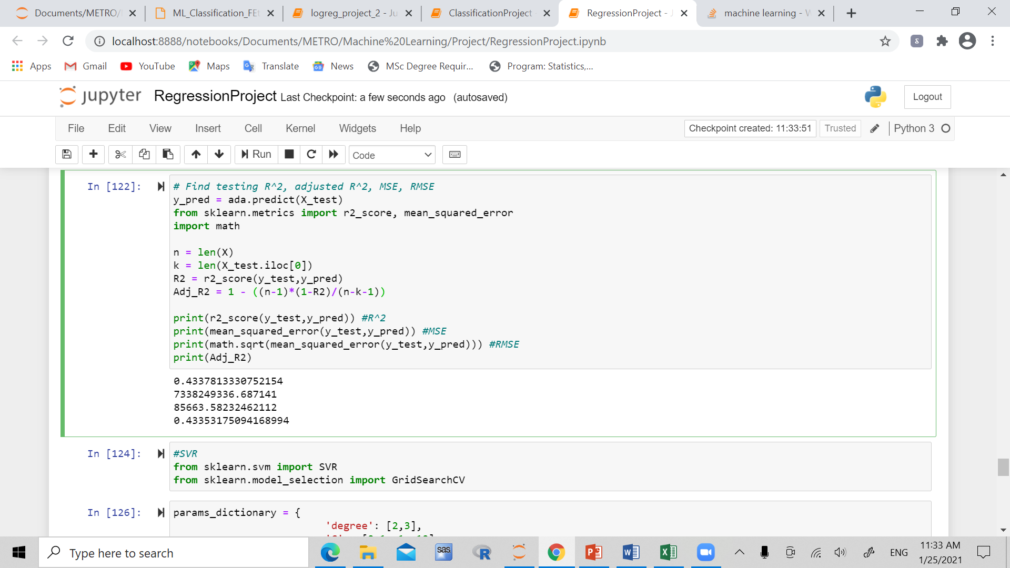

**SVR (Support Vector Regression)**

Best parameters, estimator, score:

K fold cross validated test score:

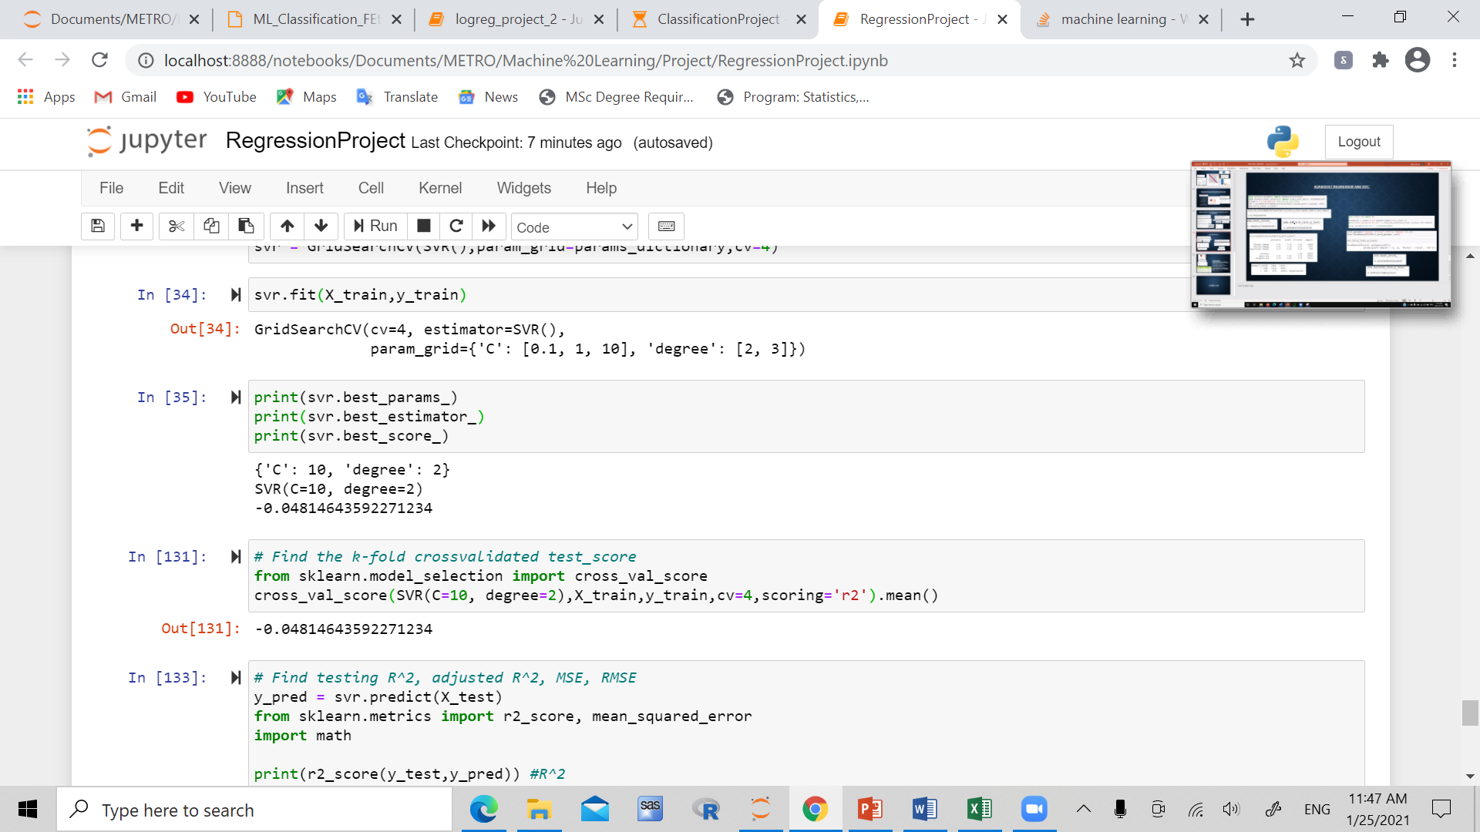

R^2, adjusted R^2, MSE, RMSE:

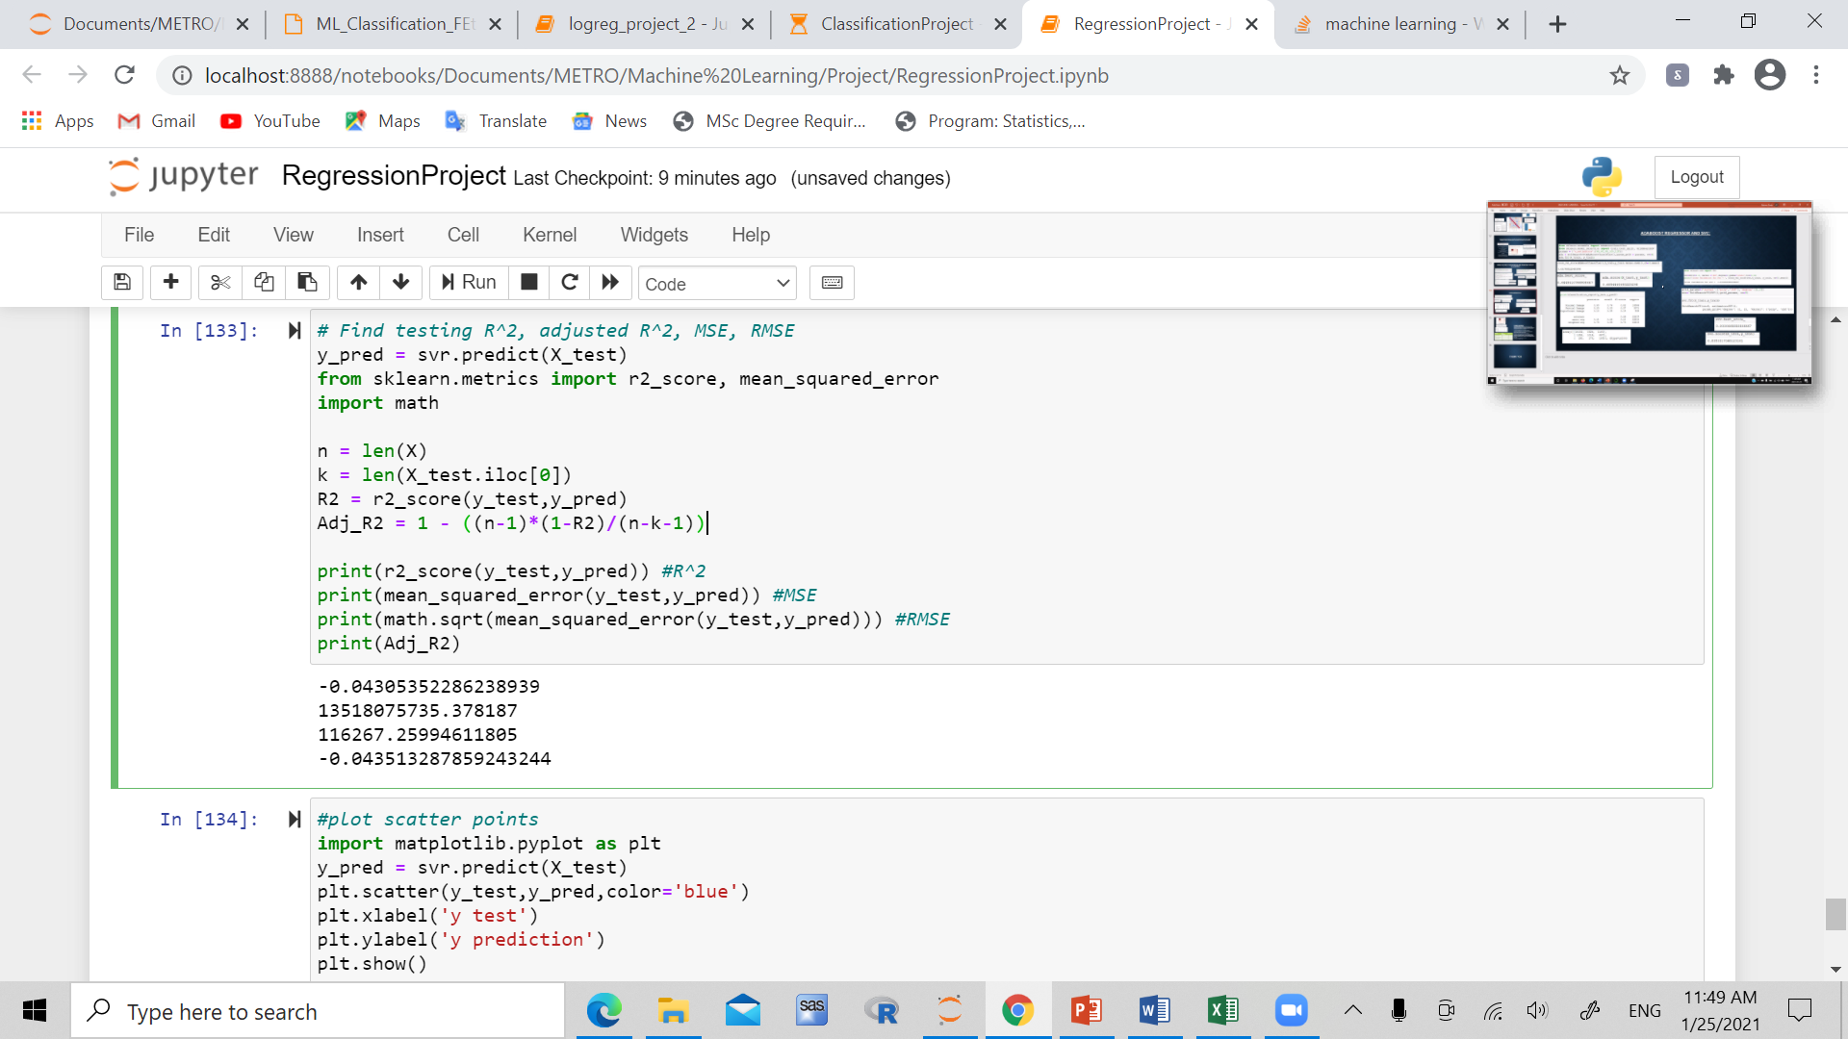

**Summary/Conclusion:**

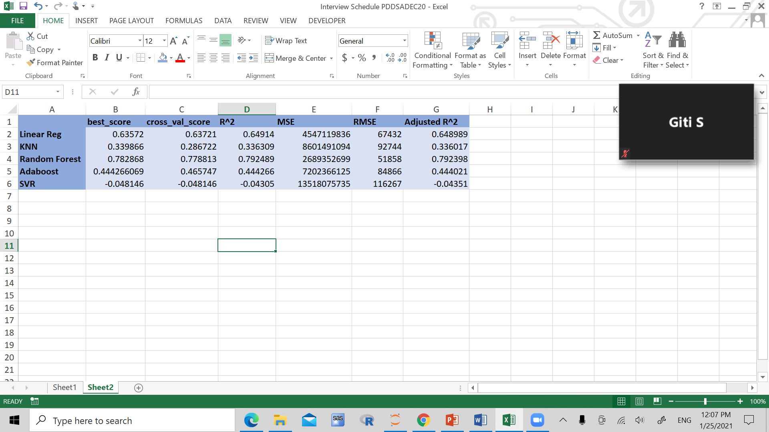

**From these summary statistics, we are able to conclude that the random forest model is the best model in this case, while the SVR model is the worst.**

**Classification data:**

*Properties of dataset:* The dataset sourced from Kaggle, is based on the job change of data scientists. A company which conducts courses among workers that successfully pass courses, and want to study whether or not these people really want to work for the company. The dataset includes 19159 observations, and 14 variables. These variables include city_code, city_development_index, gender, relevant_experience, enrolled_university, education level, major discipline, experience, company type, last new job, training hours, target.

**GOAL:** Find the model which makes the best prediction of the targeted variable.

**Data cleaning/ preprocessing**

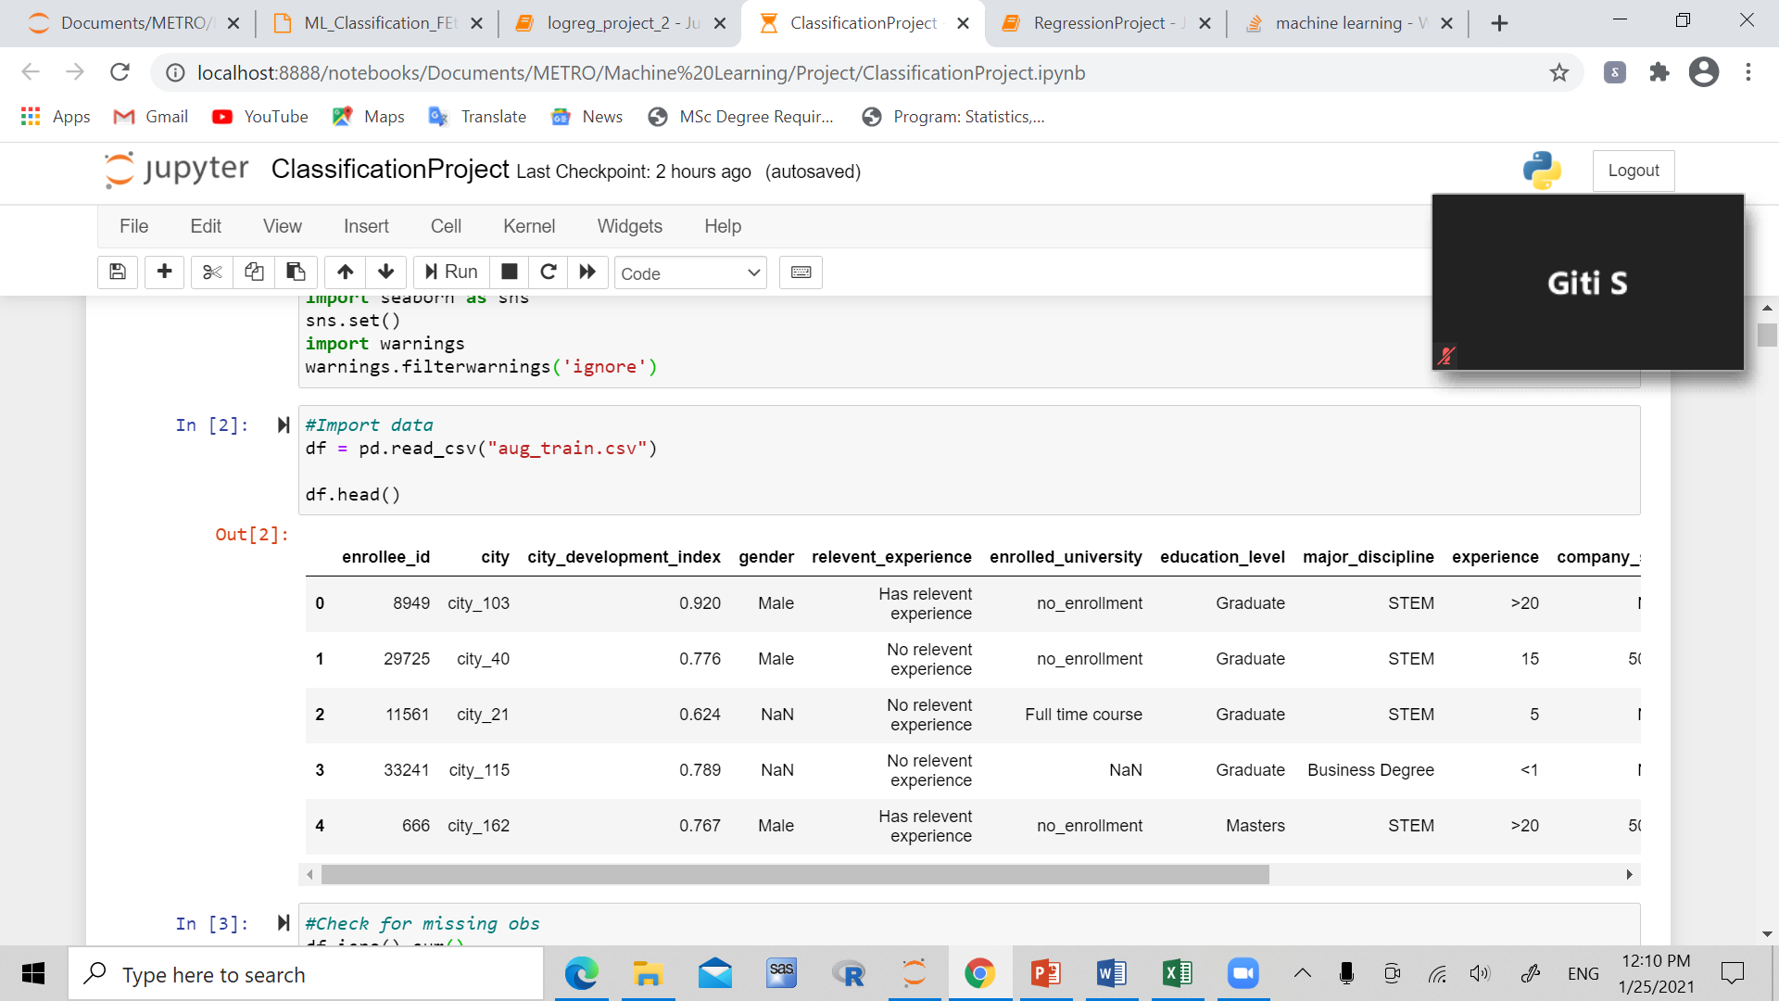

Encoding:

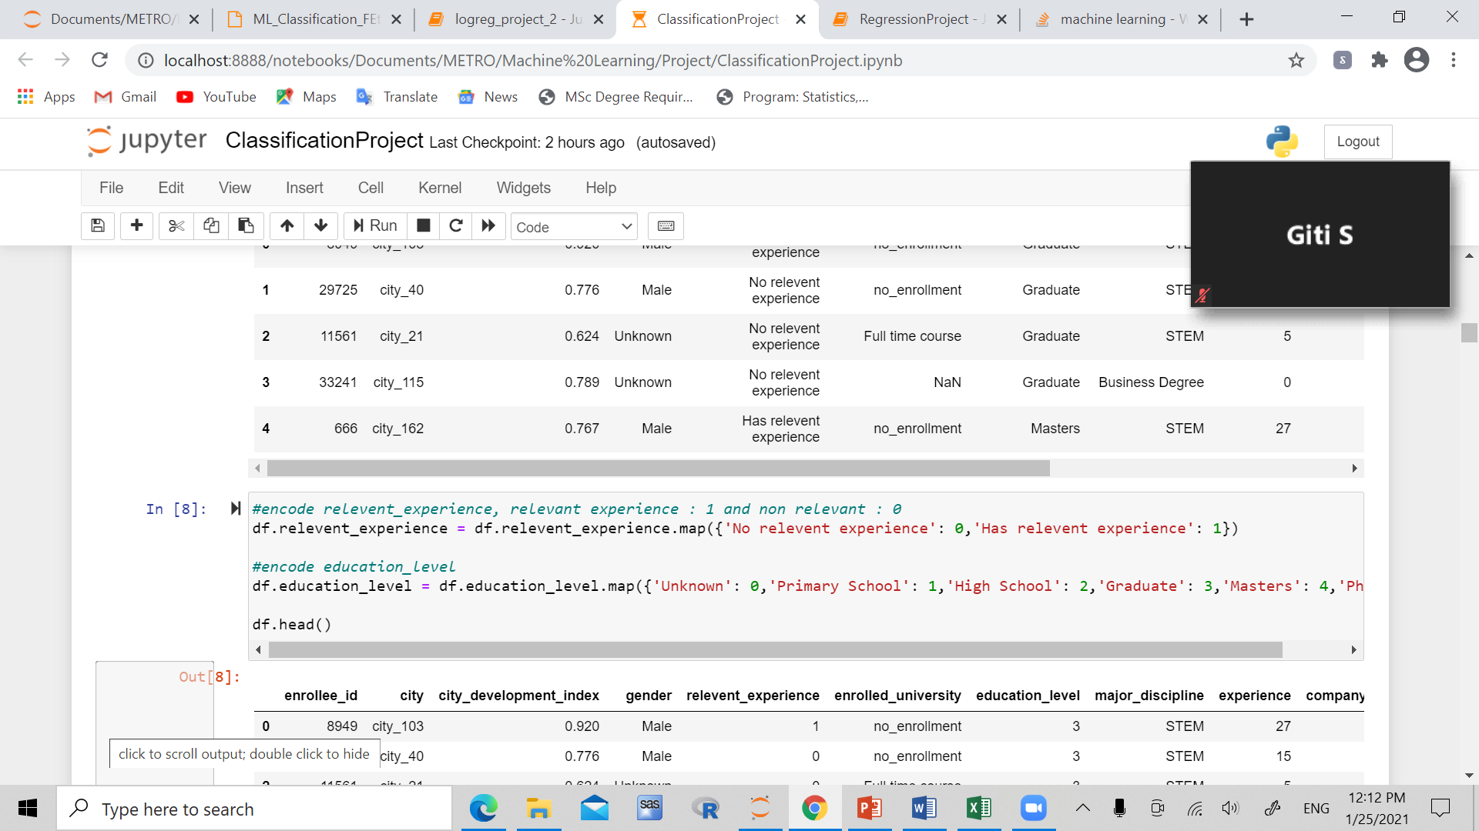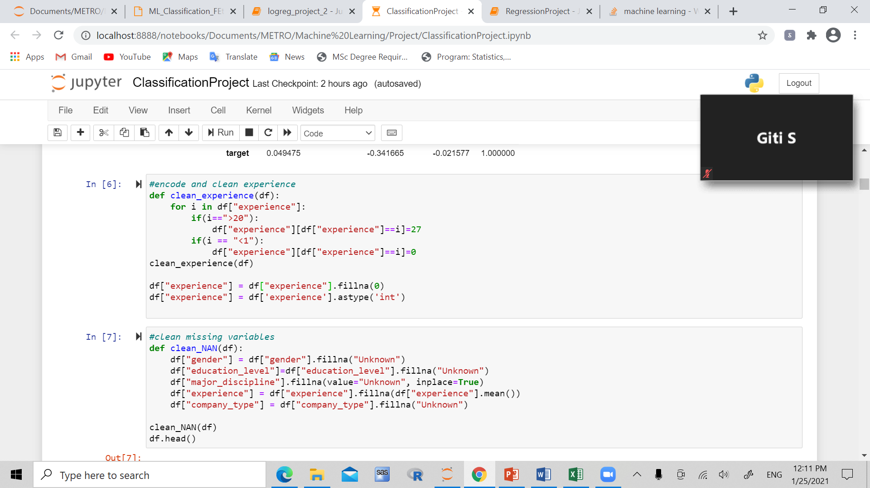

Correlation matrix:

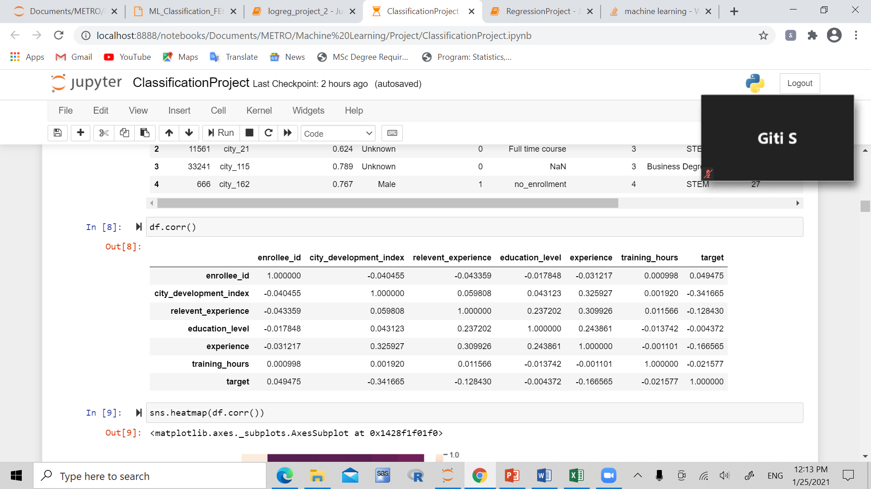

Correlation heat map:

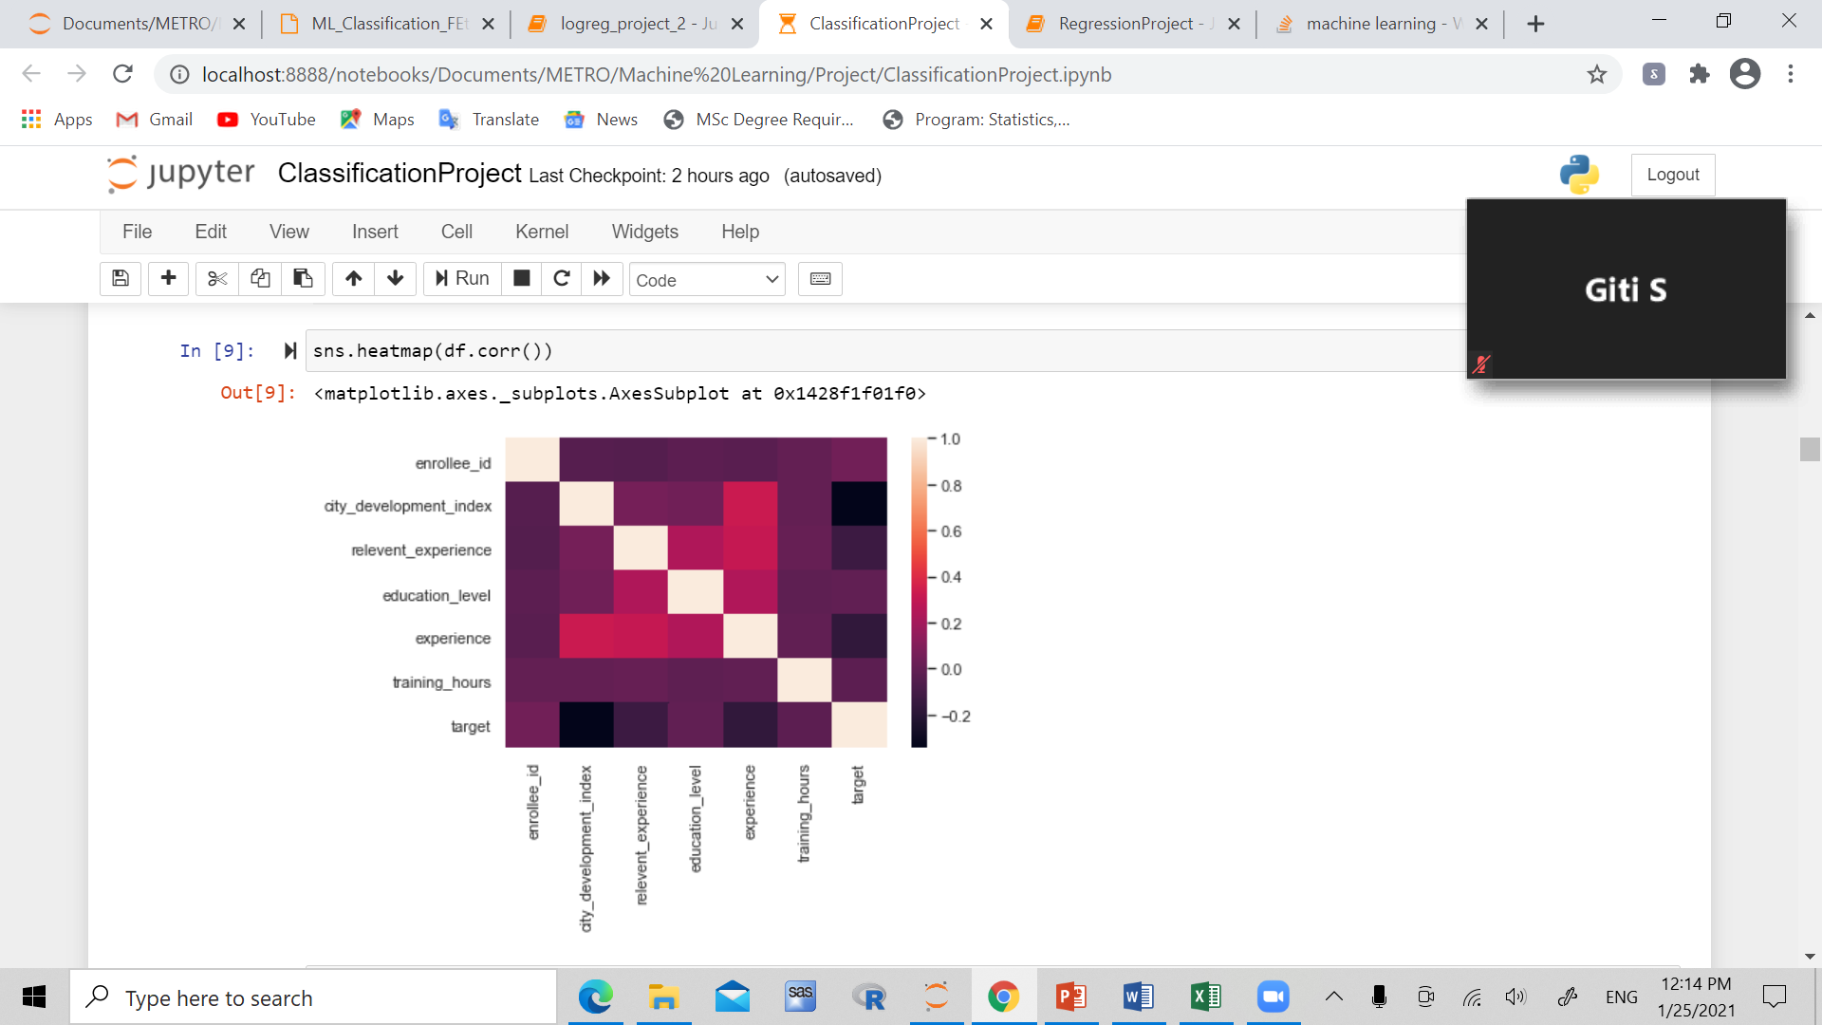

We use city_development_index, relevant_experience, education_level, experience, training_hours for the X data frame

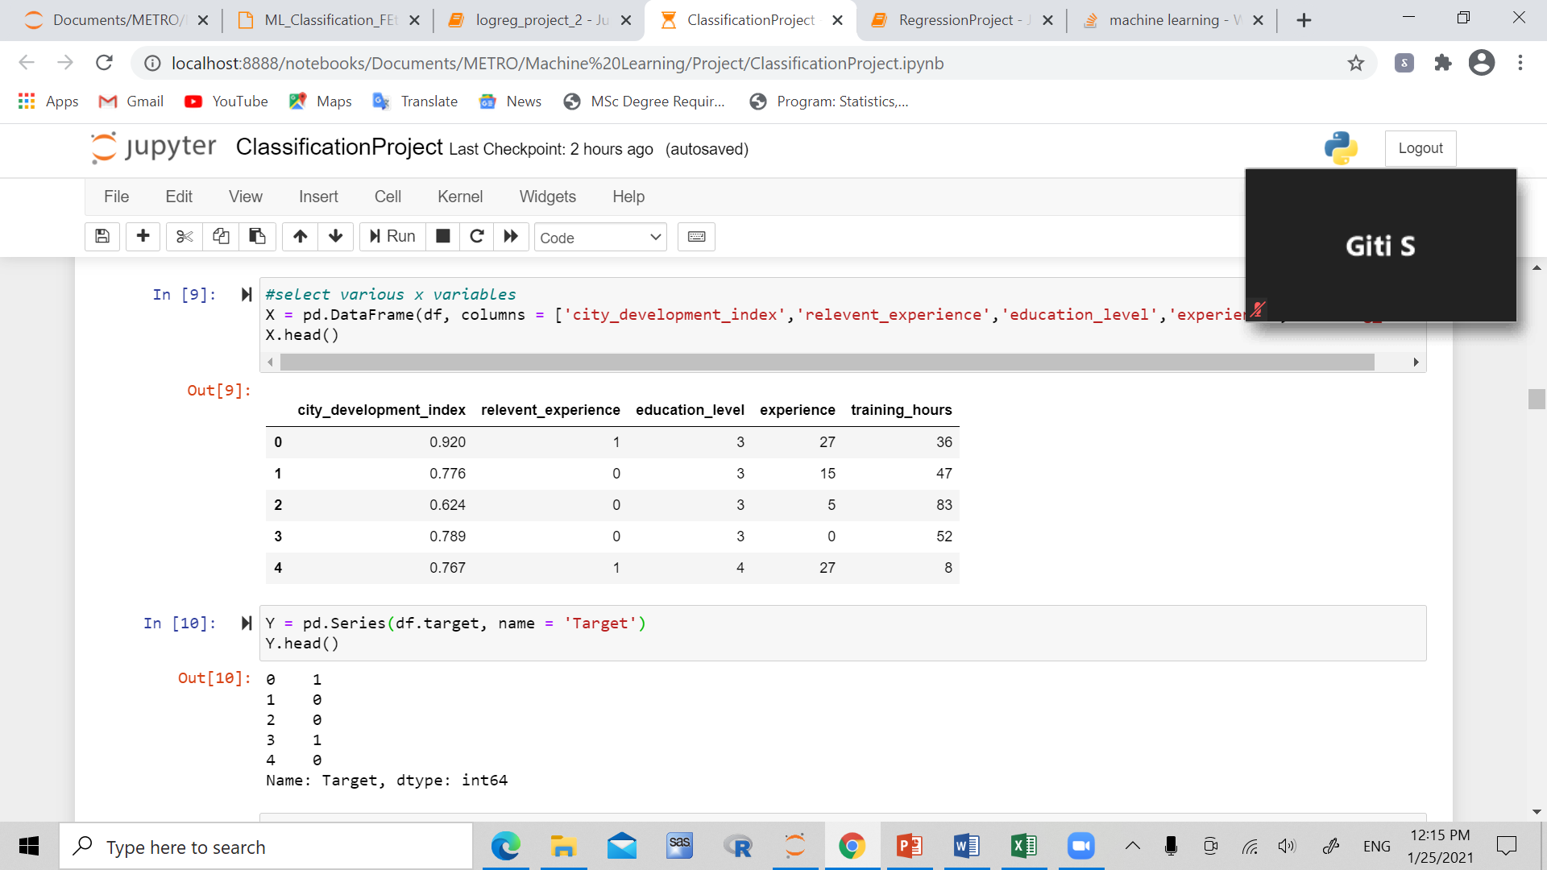

**Logistic Regression:**

Best parameters, estimator, and best score:

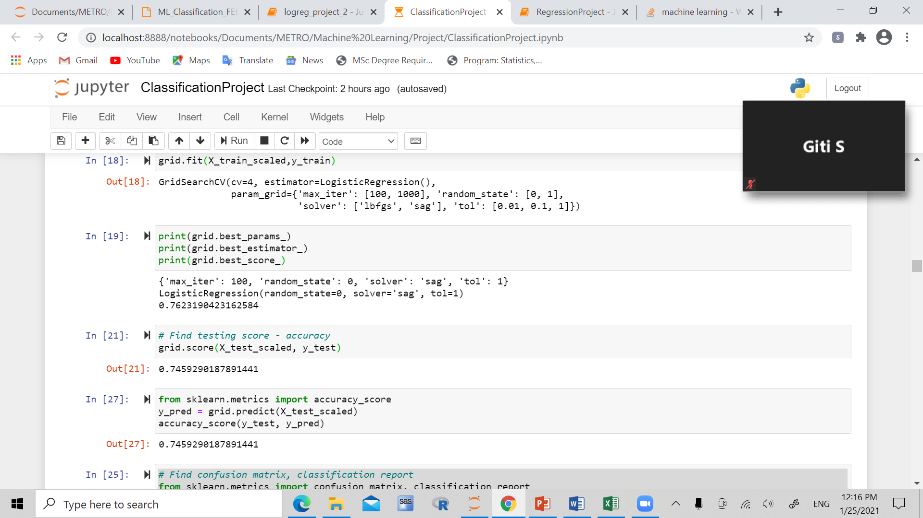

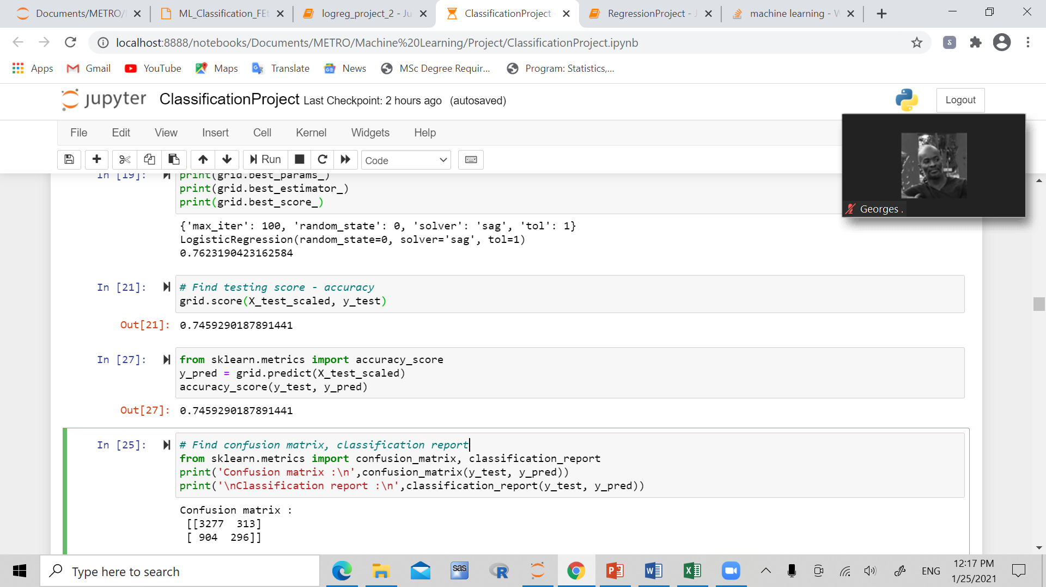

Confusion matrix/ classification report:

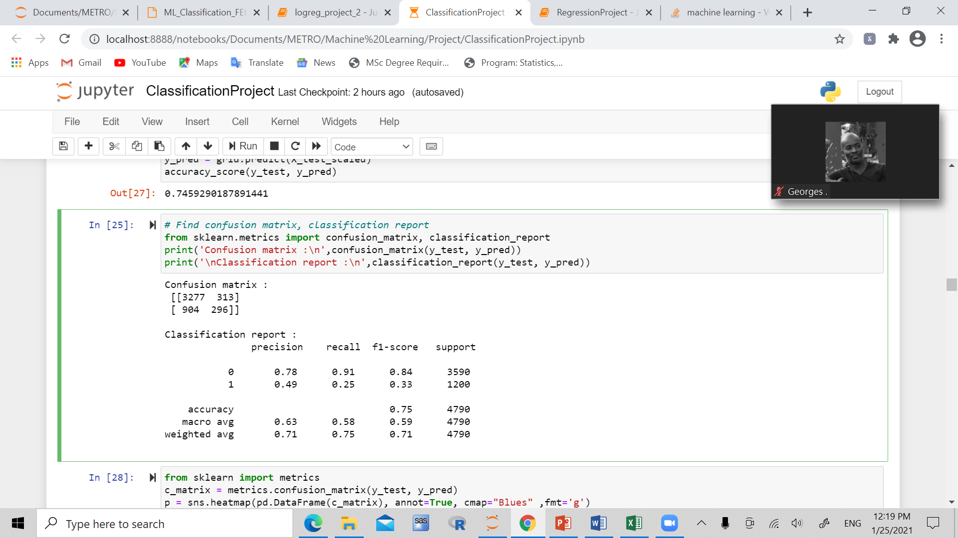 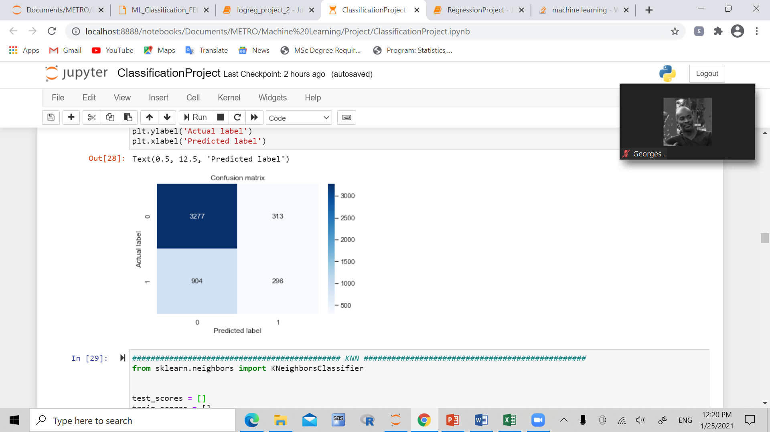

**KNN (K nearest neighbour)**

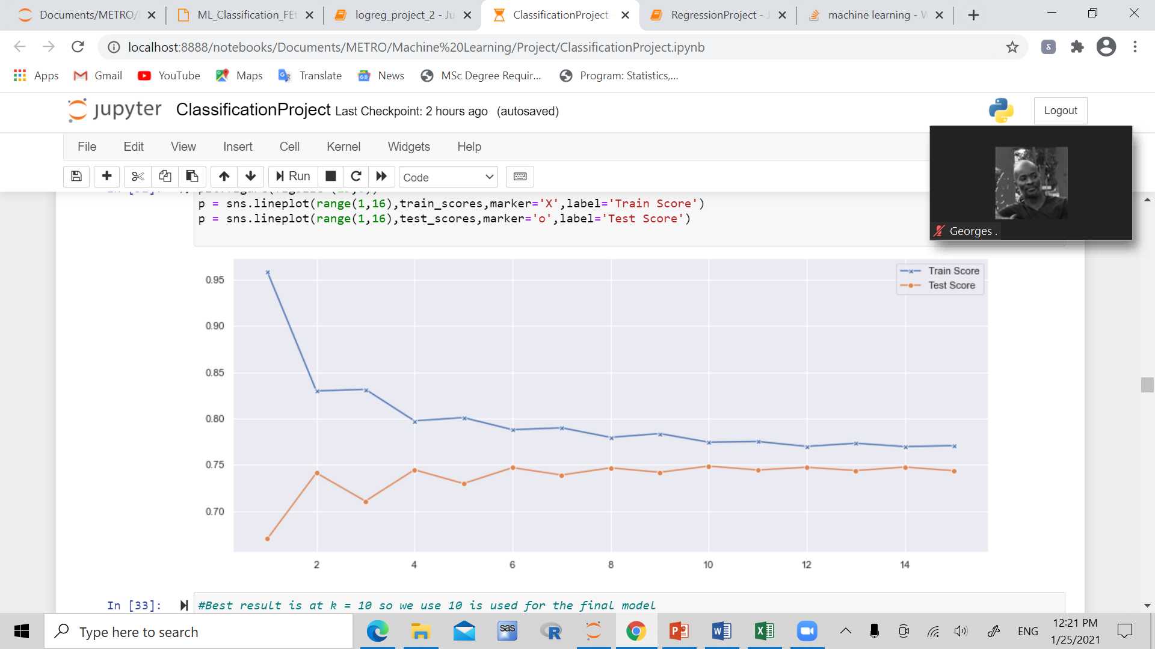

**-**Best test score result is at 10, so we use k=10 for the final model

Best parameters, estimator, and best score:

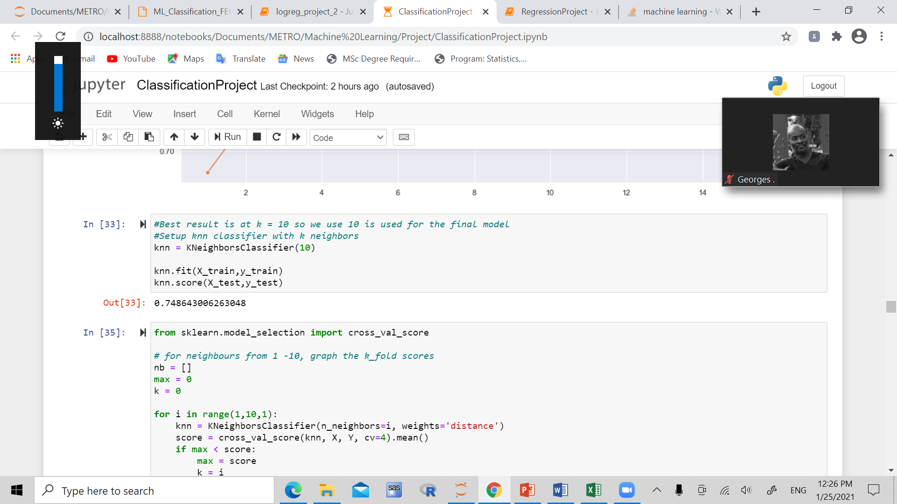



Confusion matrix/ classification report:

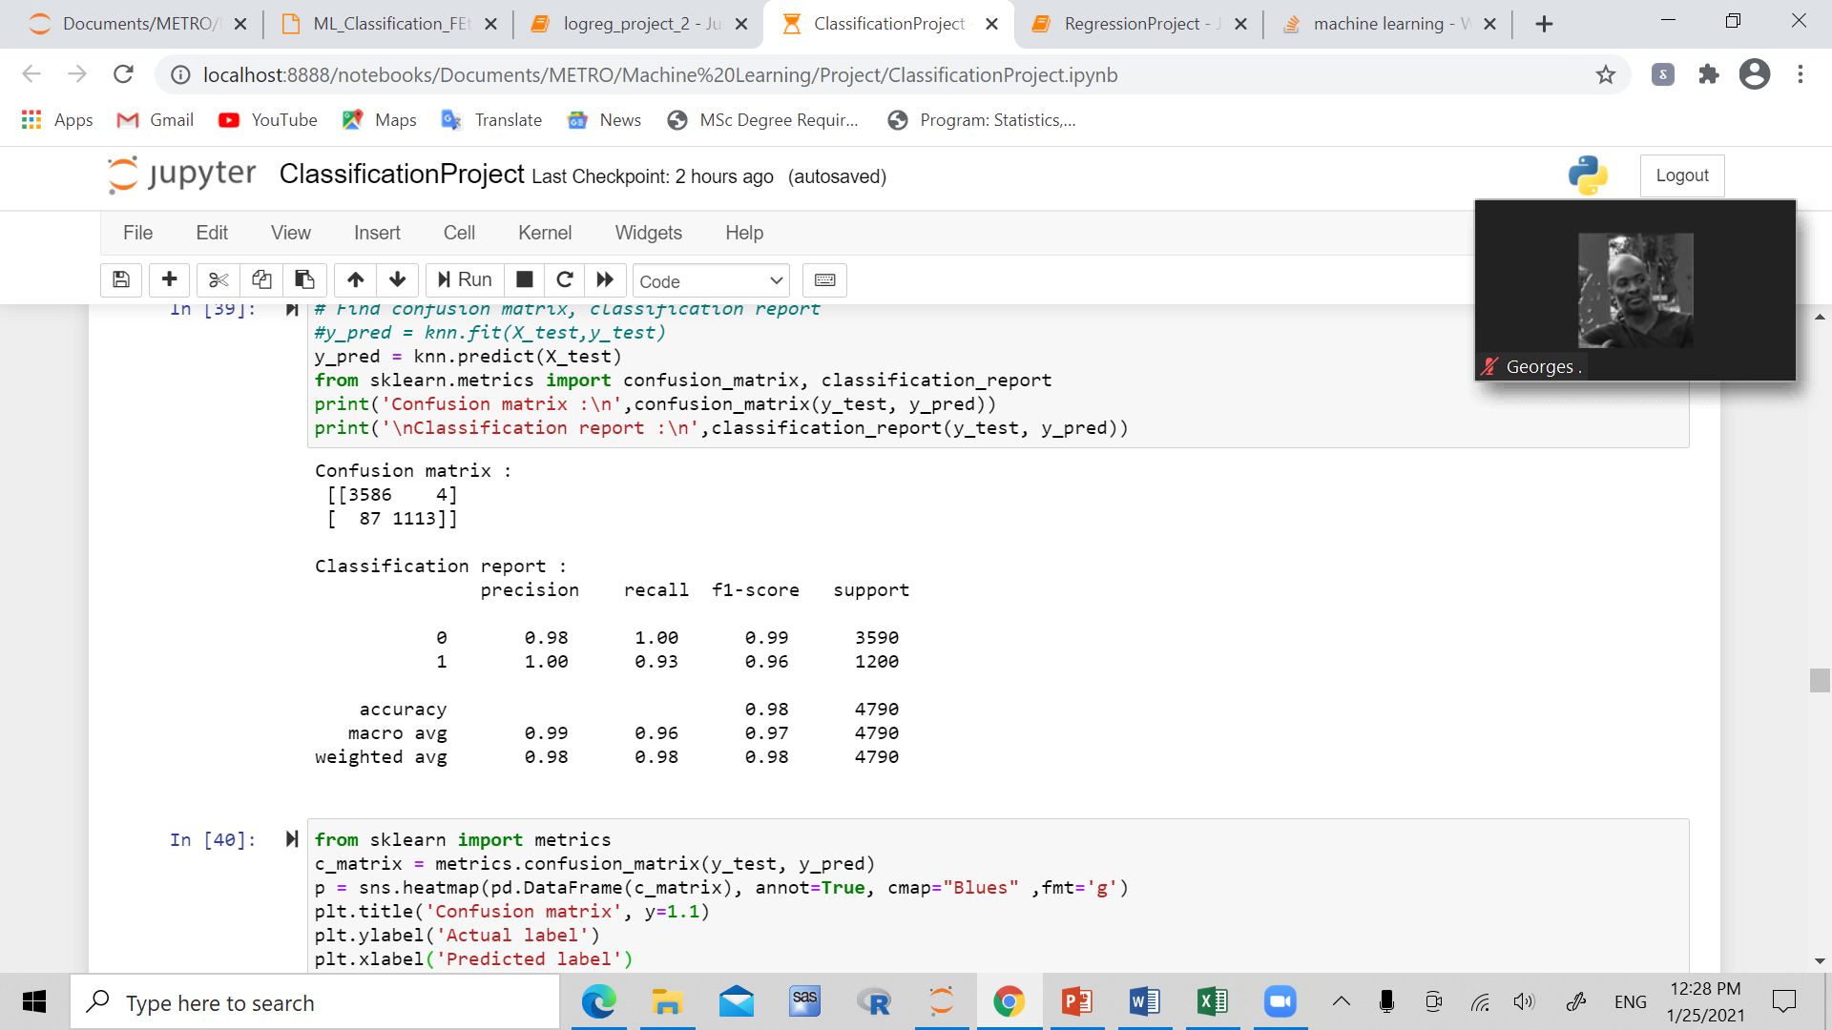

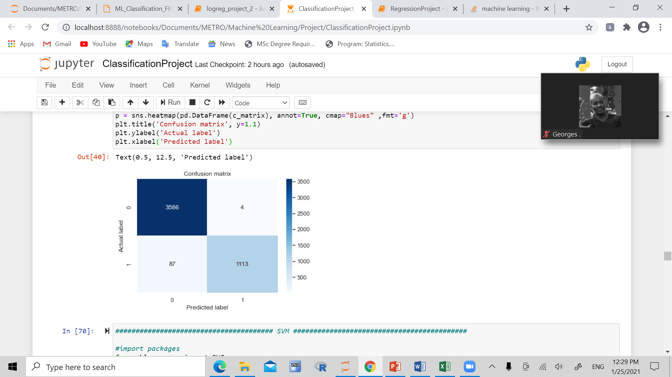

**Random Forest:**

Best parameters, estimator, and best score:

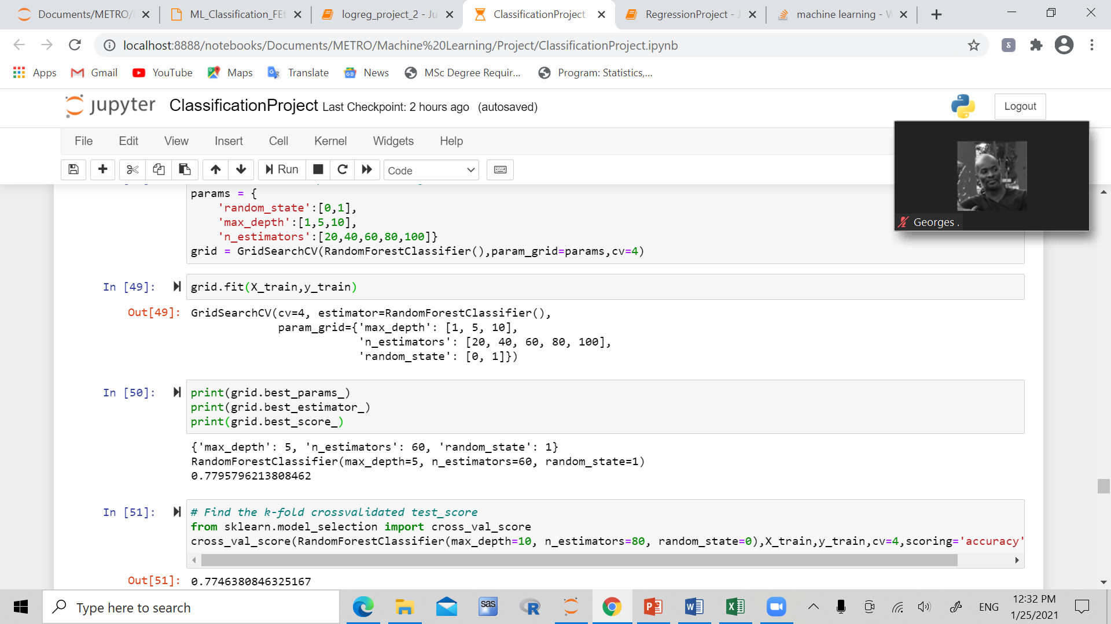

K-fold cross validation score:

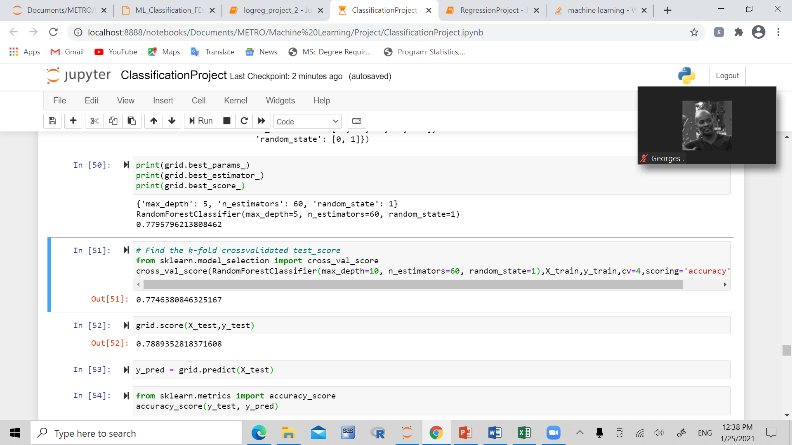

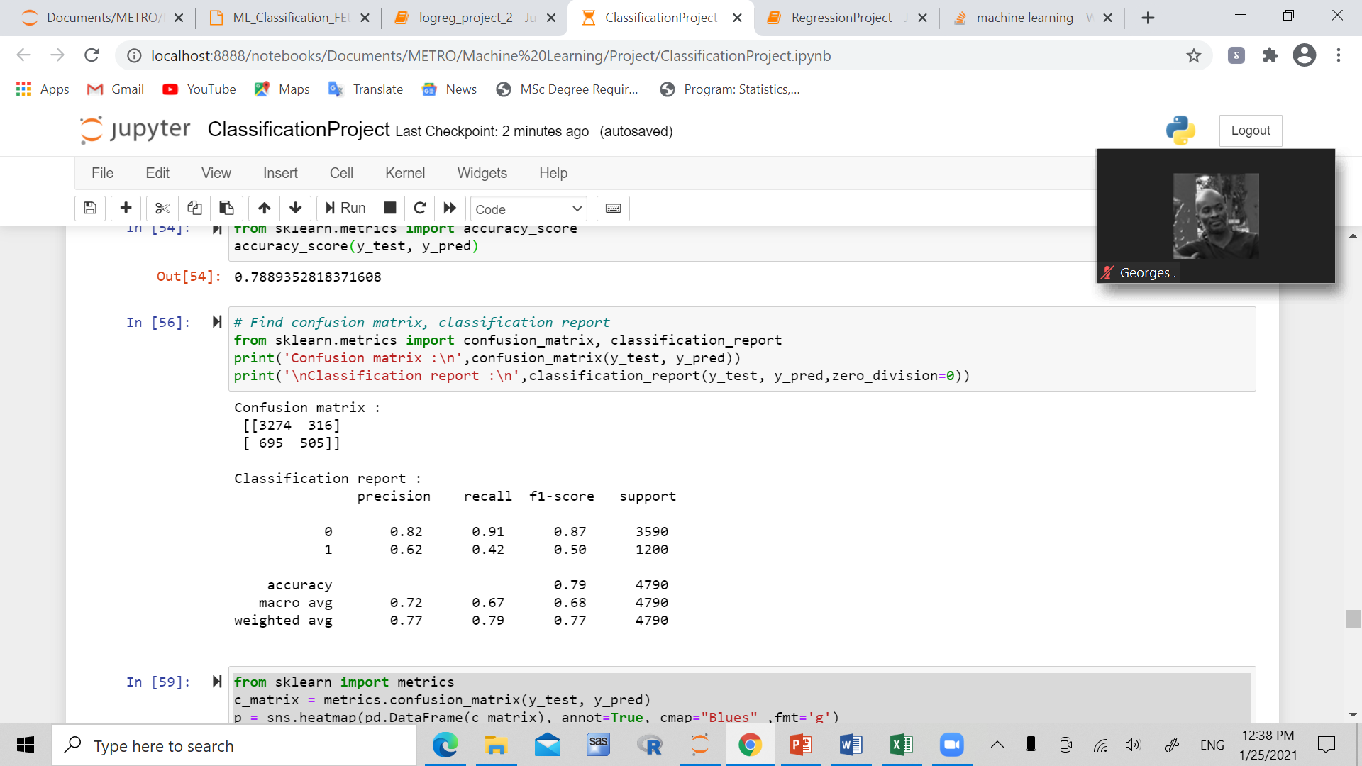Confusion matrix/ classification report:

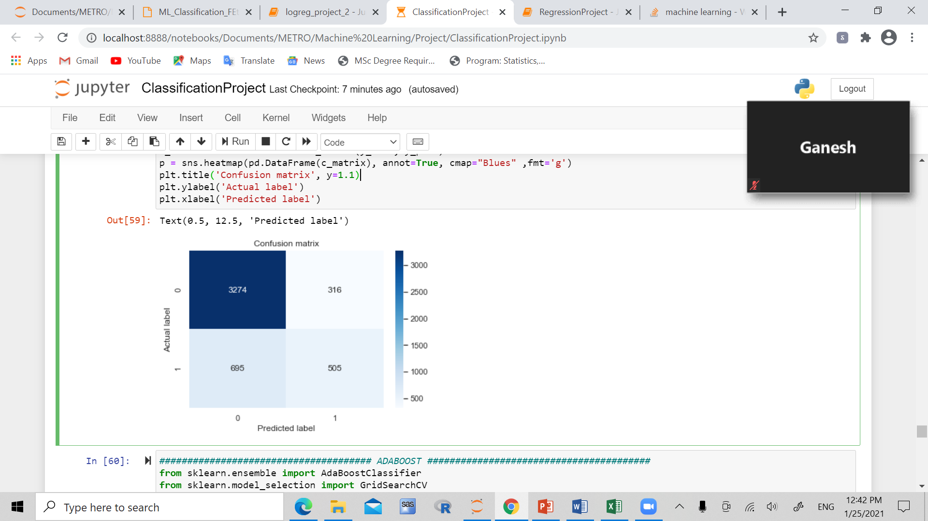

**Adaboost:**

Best parameters, estimator, and best score:

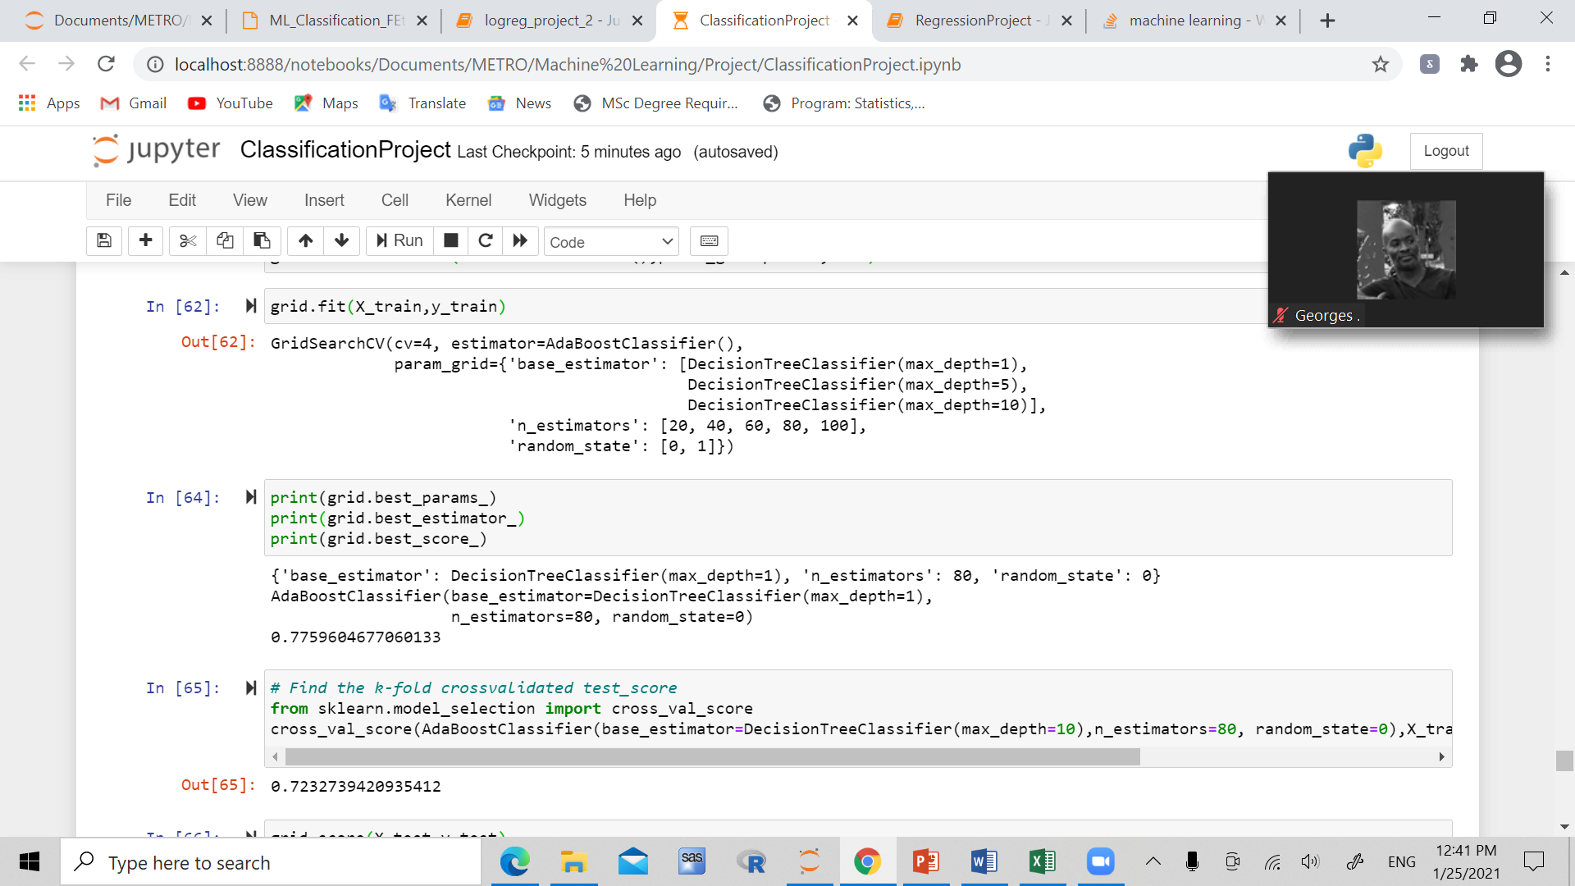

Confusion matrix/ classification report:

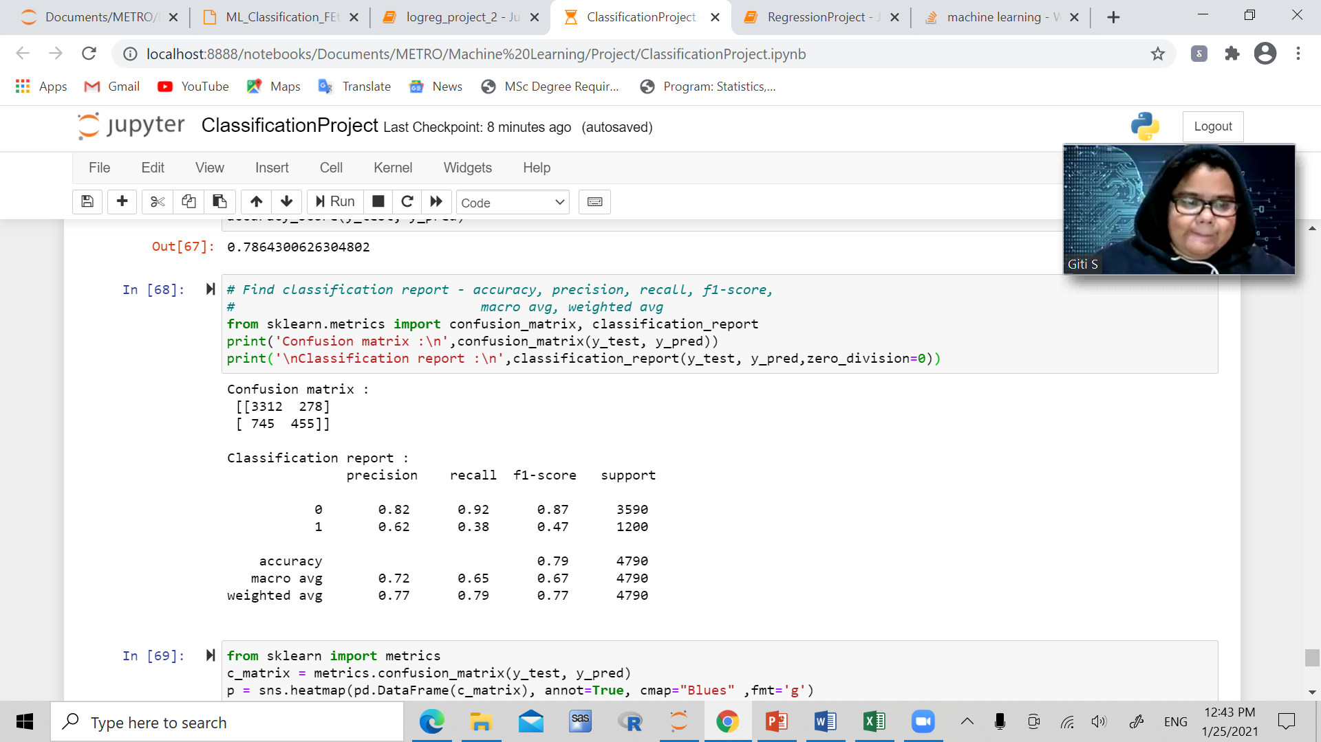

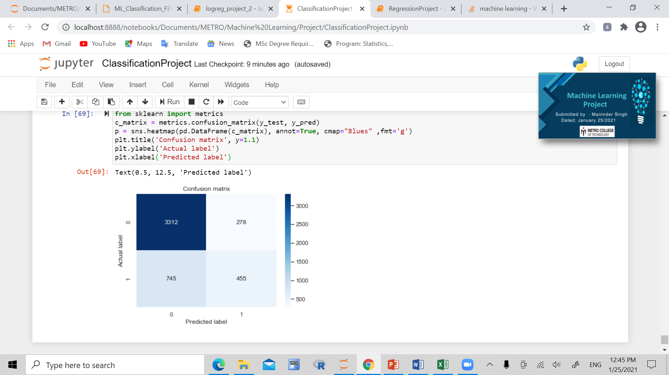

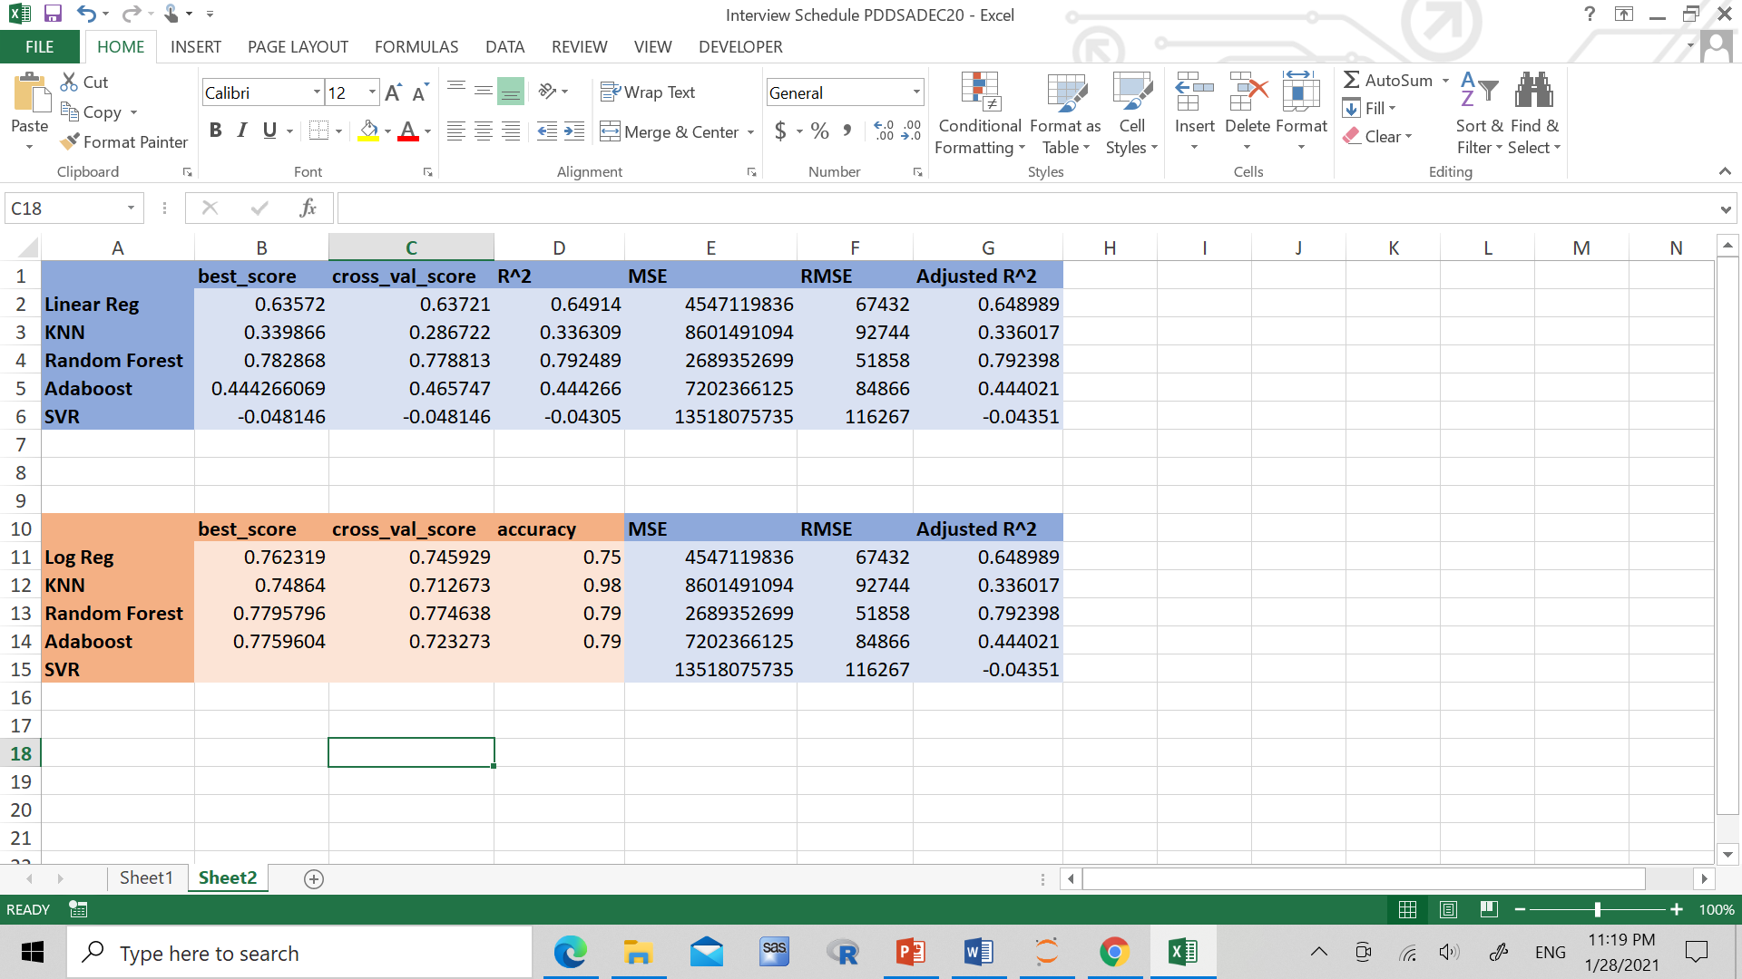

**The best model is the k nearest neighbours, which has around the same cross val score and best score as the other models. However the random forest model has 98% accuracy, while logistic regression, random forest, and adaboost models all have around 75% and 79%.**

References:

[HR Analytics: Job Change of Data Scientists | Kaggle](https://www.kaggle.com/arashnic/hr-analytics-job-change-of-data-scientists?select=aug_train.csv)

[California Housing Prices | Kaggle](https://www.kaggle.com/camnugent/california-housing-prices)